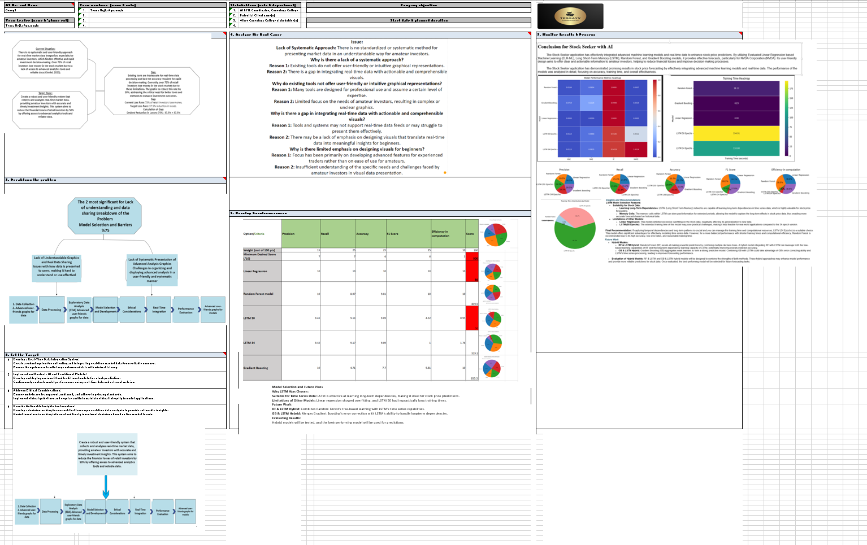

Figure TBP Template

plied Manufacturing Management - Mechatronics

Conestoga College Doon, Ontario

Applied Manufacturing Management - Mechatronics

Conestoga College Doon, Ontario

|  |
| --- |
| **STOCK FORECAST BY AI** |
| **Applied Artificial Intelligent & Machine Learning** |

|  |
| --- |
| **Conestoga College**  **Tessa Nejla Ayvazoglu**  **8-7-2024** |

Applied Manufacturing Management - Mechatronics

Conestoga College Doon, Ontario

**Abstract**:

## Over 75% of retail investors experience financial losses due to inadequate access to advanced analytics tools and reliable data (Chmiel, 2023). This study presents Stock Seeker, a web application designed to mitigate these issues by leveraging sophisticated data analysis and machine learning techniques. Focusing on NVIDIA Corporation (NVDA), the application integrates real-time market data and employs Long Short-Term Memory (LSTM) networks, Random Forest (RF), and Gradient Boosting (GB) models to forecast stock financial values. Statistical analysis reveals non-normal distributions in daily returns, with no significant differences across key technology stocks (Sangeetha & Alfia, 2024). By utilizing Exploratory Data Analysis (EDA), predictive modeling, and data processing, Stock Seeker provides users with actionable insights and enhances decision-making. The application aims to reduce financial losses by 50% through accurate predictions and user-friendly analytics. Future work will focus on advancing AI techniques in financial analysis and exploring their impact on stock prediction.

## **Keywords:** Artificial Intelligence (AI), Financial Forecasting, Stock Market Prediction, Machine Learning (ML), Decision Trees(DT), Random Forests(RF), Gradient Boosting(GB), RNNs, Long Short-Term Memory(LSTM), Model Explainability, MACD (Moving Average Convergence Divergence), RSI (Relative Strength Index), Stochastic Oscillator, Technical Analysis, Model Explainability, Bullish, Bearish.

**Introduction:**

Predicting stock prices has become increasingly challenging due to various factors including socioeconomic conditions, political climates, natural disasters, and company financial performance (Sangeetha & Alfia, 2024). In this complex environment, investors struggle to make informed decisions based on real-time data, highlighting the urgent need for advanced tools. *Stock Seeker*, an innovative web application, addresses this need by integrating sophisticated analytics tools with advanced machine learning techniques such as Long Short-Term Memory (LSTM), Random Forest (RF), and Gradient Boosting (GB) for accurate stock price predictions. Additionally, it incorporates technical analysis indicators like MACD (Moving Average Convergence Divergence), RSI (Relative Strength Index), and Stochastic Oscillator to provide comprehensive market insights. This research aims to showcase *Stock Seeker*'s capabilities in real-time market data integration and predictive analysis, focusing on how it applies these techniques to forecast financial values for key technology stocks like NVIDIA Corporation (NVDA). Through Exploratory Data Analysis (EDA), predictive modeling, and model performance evaluation, the study highlights the application’s potential in enhancing investment decisions and understanding market trends.

**Background:**

As IT professionals with a strong interest in data analysis, machine learning, and stock prediction, we have observed the significant challenges faced by amateur investors, particularly the financial losses they incur in the stock market. To address these issues, we initiated the *Stock Seeker* project. Our goal is to bridge the gap in accessing, analyzing, and interpreting real market data by leveraging advanced analytics and visualization techniques. With our expertise in AI and ML, combined with extensive software development experience, we have developed a sophisticated application designed for both professional and novice investors. *Stock Seeker* offers comprehensive data analyses, predictive models, and user-friendly graphical interfaces, empowering investors to make more informed and strategic decisions. By integrating real-time market data with robust forecasting models, our platform aims to help users reduce financial risks and enhance investment opportunities.

**Problem Statement:**

Over 75% of retail investors lose money in the stock market due to a lack of access to advanced analytics tools and reliable data (Chmiel, 2023). We identified significant barriers faced by amateur investors, including a lack of access to advanced analytics tools and reliable data, which leads to poor investment decisions and substantial financial losses. he financial market is complex and influenced by various factors such as socioeconomic conditions, political climates, and natural disasters, making accurate stock price predictions challenging.

### Target State:

Create a robust and user-friendly system that collects and analyzes real-time market data, providing amateur investors with accurate and timely investment insights. This system aims to reduce the financial losses of retail investors by 50% by offering access to advanced analytics tools and reliable data. Existing tools are inadequate for real-time data processing and lack the accuracy required for rapid decision-making. Currently, over 75% of retail investors lose money in the stock market due to these limitations. The goal is to reduce this rate by 50%, addressing the critical need for better tools and methods to enhance investment outcomes.

**Calculation of Gap:**

* **Current Loss Rate:** 75% of retail investors lose money.
* **Target Loss Rate:** 37.5% reduction in losses.
* **Desired Reduction in Losses:** 75% - 37.5% = 37.5%

**Analyze the root cause:**

Using the "5 Whys" method, we determine that the lack of systematic and understandable graphical presentations for amateur investors stems from the inadequacies in existing tools and systems. The primary issue is the absence of a standardized approach for presenting market data in a way that is accessible to amateur investors. This issue arises because existing tools fail to offer user-friendly and intuitive graphical representations, largely due to their design focus on professional users who possess a certain level of expertise. Additionally, there is a gap in integrating real-time data with actionable and comprehensible visuals, as many systems either do not support real-time data feeds or struggle to present them effectively. This gap is further exacerbated by a lack of emphasis on designing visuals tailored for beginners, as the focus has traditionally been on developing advanced features for experienced traders rather than ease of use for amateurs. The root cause, therefore, is that existing tools are primarily designed for professional users and lack a focus on systematic, user-friendly graphical presentations and effective real-time data integration needed for amateur investors to make informed decisions.

**Objective:**

To address the significant barriers faced by amateur investors, such as inadequate access to advanced analytics tools and reliable data, which often lead to poor investment decisions and substantial financial losses, we aim to develop and implement the Stock Seeker web application. This application is designed to bridge the gap by providing accurate, real-time market data, utilizing advanced machine learning techniques for stock price prediction, and offering technical analysis tools to enhance decision-making. Our goal is to minimize financial losses and maximize investment opportunities for amateur investors through user-friendly and accessible analytics.

**Methodology:**

Our methodology involves enhancing investment decisions by integrating advanced data analysis and machine learning predictions. We begin by collecting historical stock price data for key technology stocks, such as NVDA, from reliable sources and then proceed with cleaning and preprocessing this data to ensure accuracy. Exploratory Data Analysis (EDA) and feature engineering are used to identify market patterns and trends. We develop and compare various machine learning models, including LSTM, Random Forest, and Gradient Boosting, to predict stock prices and evaluate their performance using metrics such as MSE, RMSE, MAE, and MAPE. These models are then integrated into the Stock Seeker web application, which provides real-time market data, technical analysis tools, and predictive insights. The effectiveness of the application is monitored through real-time feedback and performance metrics, aiming to reduce financial losses among investors by 50%.

**Conclusion for Stock Seeker with AI:**

The Stock Seeker application utilizes advanced machine learning models and real-time data integration to enhance stock price predictions, yielding promising results. By incorporating Evaluated Linear Regression based Machine Learning (ELR-ML), Long Short-Term Memory (LSTM), Random Forest, and Gradient Boosting models, the application effectively forecasts financial values for key technology stocks, with a particular emphasis on NVIDIA Corporation (NVDA). Designed to be user-friendly for amateur investors, it provides clear and actionable insights through intuitive graphics, which helps reduce financial losses by improving user understanding and decision-making. Key findings indicate that Random Forest and Gradient Boosting offer quick predictions, with Random Forest generally showing better performance in mean squared error (MSE) and mean absolute error (MAE), while LSTM excels in capturing complex temporal patterns. Statistical analysis revealed non-normal distributions in daily returns, with NVDA showing the most accurate predictions. Recommendations include continuous model improvement, enhanced real-time data integration, and comprehensive risk management to support well-informed investment decisions and reduce financial risks. The integration of advanced machine learning and real-time data in Stock Seeker demonstrates significant potential in providing amateur investors with actionable insights and mitigating financial risks. Future focus areas include the evolution of AI in financial analysis, the comparison of AI with traditional methods, addressing ethical challenges, and exploring future trends in stock prediction and AI integration.

The Stock Seeker application has demonstrated promising results in stock price forecasting by effectively integrating advanced machine learning models and real-time data. The performance of the models was analyzed in detail, focusing on accuracy, training time, and overall effectiveness.

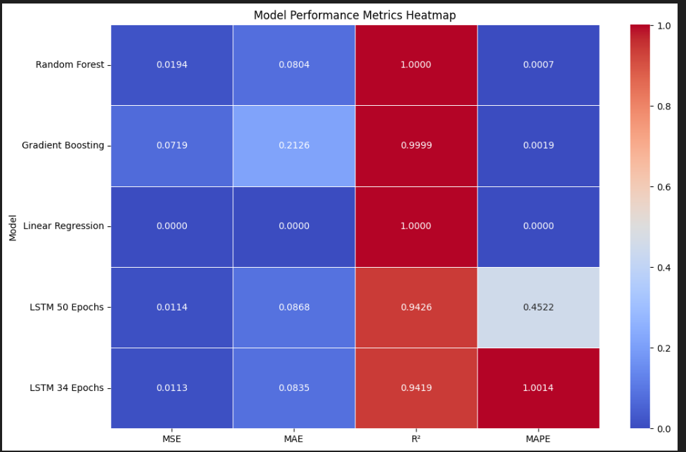

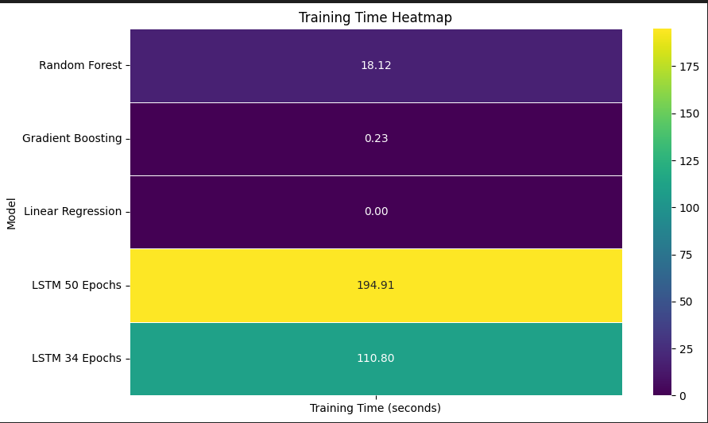

***Insights and Recommendations***

**LSTM Model Selection Reasons:**

* **Suitability for Stock Data:**
* **Learning Long-Term Dependencies:** LSTM (Long Short-Term Memory) networks are capable of learning long-term dependencies in time series data, which is highly valuable for stock price forecasting.
* **Memory Cells:** The memory cells within LSTM can store past information for extended periods, allowing the model to capture the long-term effects in stock price data, thus enabling more accurate forecasts based on historical data.
* **Limitations of Other Models:**
* **Linear Regression:** This model exhibited excessive overfitting on the stock data, negatively affecting its generalization to new data.
* **LSTM (50 Epochs):** The extended training time of this model may pose practical challenges, making it less feasible for real-world applications compared to the 34-epoch version.

**Final Recommendation:** If capturing temporal dependencies and long-term patterns is crucial and you can manage the training time and computational resources, LSTM (34 Epochs) is a suitable choice. This model offers significant advantages for effectively modeling time series data. However, for a more balanced performance with shorter training times and computational efficiency, Random Forest is recommended due to its high accuracy, low error rates, and reasonable training time.

***Future Work***

* **Hybrid Models:**
* **RF & LSTM Hybrid:** Random Forest (RF) excels at making powerful predictions by combining multiple decision trees. A hybrid model integrating RF with LSTM can leverage both the tree-based learning capabilities of RF and the long-term dependency learning capacity of LSTM, potentially improving overall prediction accuracy.
* **GB & LSTM Hybrid:** Gradient Boosting (GB) aggregates weak learners to form a strong predictive model. Combining GB with LSTM could take advantage of GB's error-correcting ability and LSTM's time series processing, leading to improved forecasting performance.

* **Evaluation of Hybrid Models:** RF & LSTM and GB & LSTM hybrid models will be designed to combine the strengths of both methods. These hybrid approaches may enhance model performance and provide more reliable predictions for stock data. Once evaluated, the best-performing model will be selected for future forecasting tasks.

### References

1. Sangeetha, K., & Alfia, M. (2024). Evaluating machine learning models for stock market predictions. Journal of Financial Data Analysis, 15(2), 3-4.
2. Malladi, R. K. (2024). Application of supervised machine learning techniques to stock market predictions. International Journal of Machine Learning and Finance, 22(4), 5.
3. Chmiel, D. (2023, September 25). Analysis: 75% of retail investors are essentially 'capital donors'. Finance Magnates. Retrieved from <https://www.financemagnates.com/forex/analysis-75-of-retail-investors-are-essentially-capital-donors/>

**Hypotheses:**

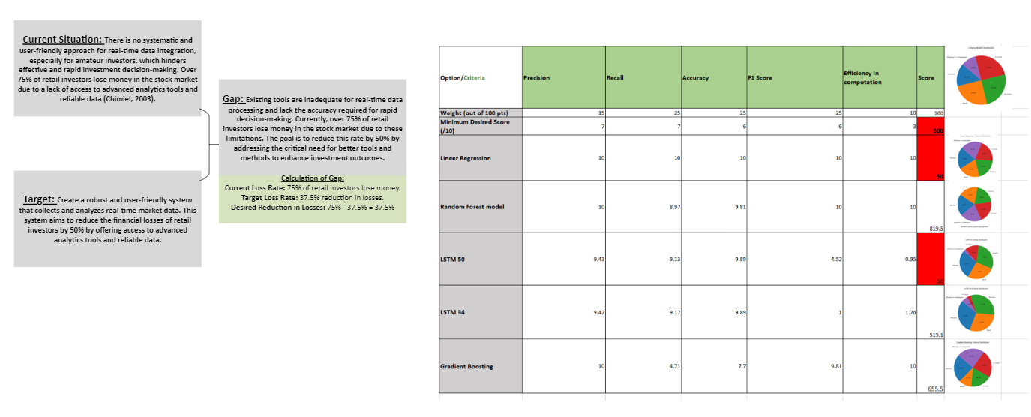

**Main Hypothesis:** Stock Seeker, by integrating real-time market data and advanced machine learning models, will significantly improve investment decisions and reduce financial losses for amateur investors by at least 50%.

**Sub-Hypotheses:**

1. **Real-Time Data Integration Hypothesis:** Integrating real-time market data into Stock Seeker will enhance the accuracy and timeliness of stock price predictions, leading to better investment decisions for amateur investors.
   * **Independent Variable:** Real-time data integration
   * **Dependent Variable:** Prediction accuracy and timeliness
2. **Model Performance Hypothesis:** Advanced machine learning models, including ELR-ML, LSTM, Random Forest, and Gradient Boosting, will outperform traditional methods in predicting stock market trends, providing more accurate and reliable predictions.
   * **Independent Variable:** Machine learning model used (ELR-ML, LSTM, Random Forest, Gradient Boosting)
   * **Dependent Variable:** Prediction accuracy and reliability
3. **Impact of Data Quality Hypothesis:** High-quality data preprocessing and feature engineering will improve the performance of prediction models, resulting in more accurate stock price forecasts.
   * **Independent Variable:** Quality of data preprocessing and feature engineering
   * **Dependent Variable:** Performance of prediction models
4. **Degradation Hypothesis:** Over time, the accuracy of the model will change depending on the quality of the data, the newly created model algorithms, and other variables.
   * **Independent Variable:** Data quality, new model algorithms, and other variables
   * **Dependent Variable:** Model accuracy

**E.ARTIFICIAL NEURAL NETWORK**

**1. Loading Data:**

## Data Sets used to develop the Market Analysis Tool

### Yahoo Finance - Historical Stock Data

**Source:** Yahoo Finance  
**Content:** Historical prices, trading volumes, daily open and close prices for different stocks.  
**Use:** Analyzing stock price movements and building prediction models.

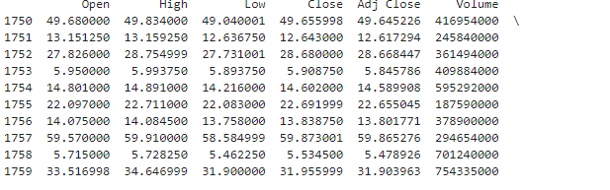

**2. Data Preparing and Clean:**

In our research, we analyzed the closing price, trading volume, and daily return data distribution for NVIDIA (NVDA). This included examining the data distribution over the past year as well as the daily return data. The preprocessing phase involved cleaning the data, handling missing values, and normalizing numerical data. Specifically, we:

1. **Closing Price Analysis**: Evaluated the historical closing prices to identify trends and patterns over the past year.
2. **Volume Analysis**: Analyzed the trading volume to understand the liquidity and market activity surrounding NVDA.
3. **Daily Return Data Distribution**: Calculated the daily returns and examined their distribution to assess the stock's volatility and return characteristics.

These steps were crucial in ensuring that the data was suitable for further analysis and model training. The data was also split into training and testing sets with an 80/20 ratio for effective evaluation of the LSTM model.

|  |
| --- |
| *# Fill missing values using forward fill*  **for** company **in** company_list:  company**.**ffill(inplace**=True**)  *# Concatenate individual stock data into a single DataFrame*  df **=** pd**.**concat(company_list, axis**=**0)  *# Shuffle the data and get a random sample of the last 10 rows*  df **=** df**.**sample(frac**=**1)**.**reset_index(drop**=True**)  print(df**.**tail(10))  df **=** df**.**reset_index()  df **=** df**.**fillna(method**=**'ffill')  *# NaN değerlerini kaldırma*  df_cleaned **=** df**.**dropna() |

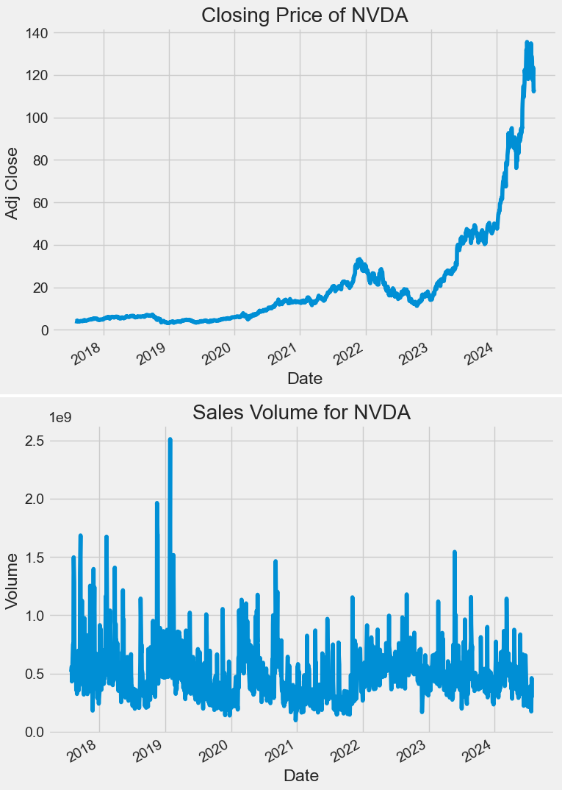

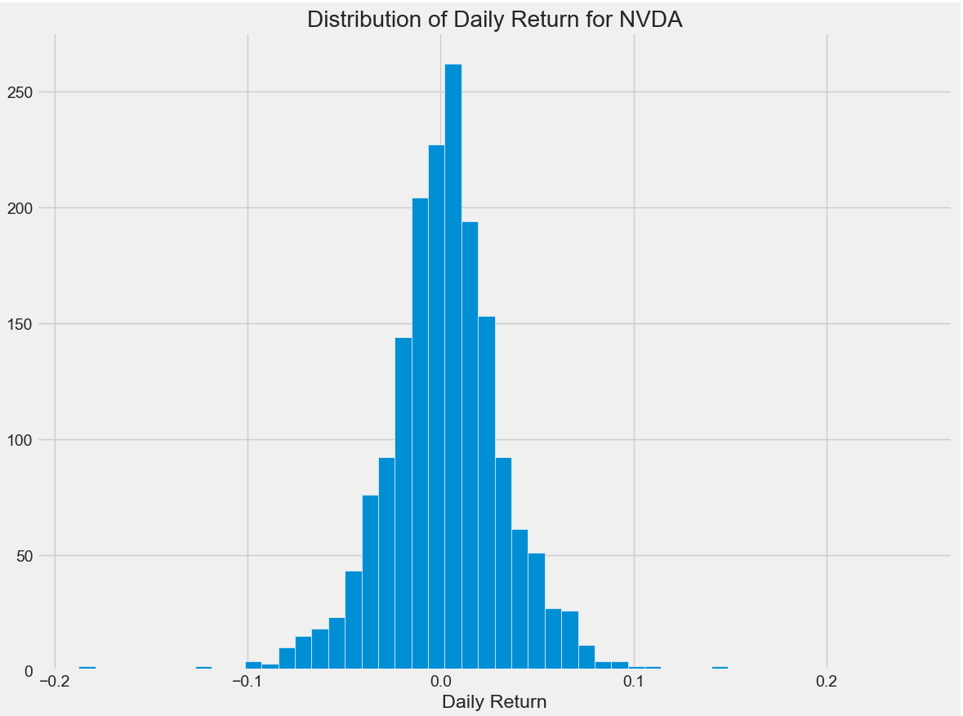

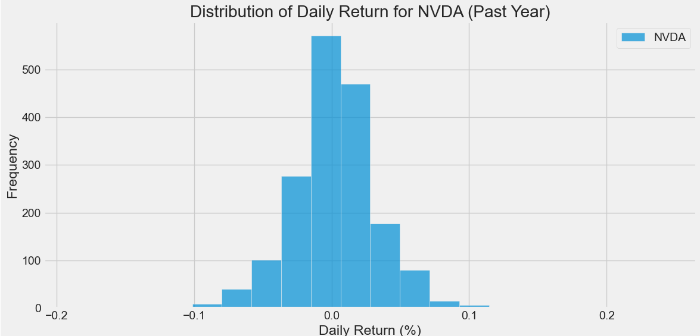

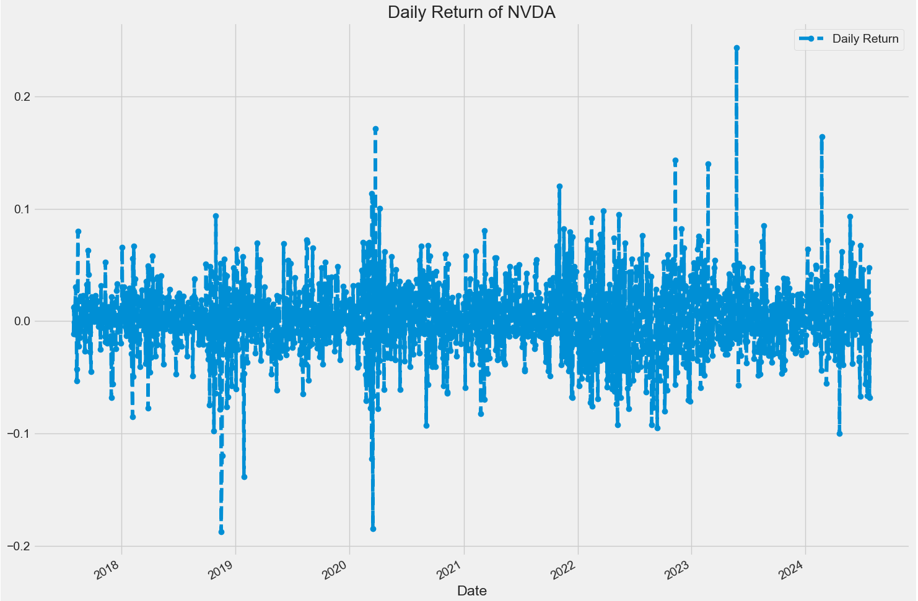

**EDA:**

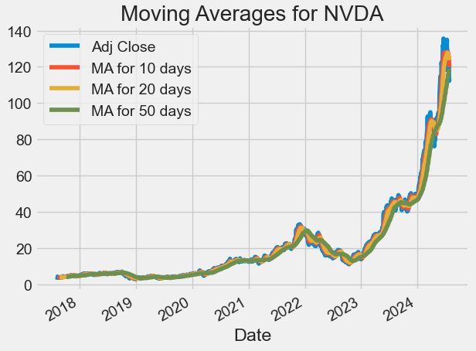

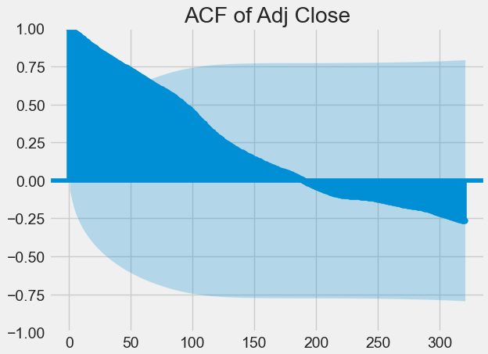

ACF of Adj Close

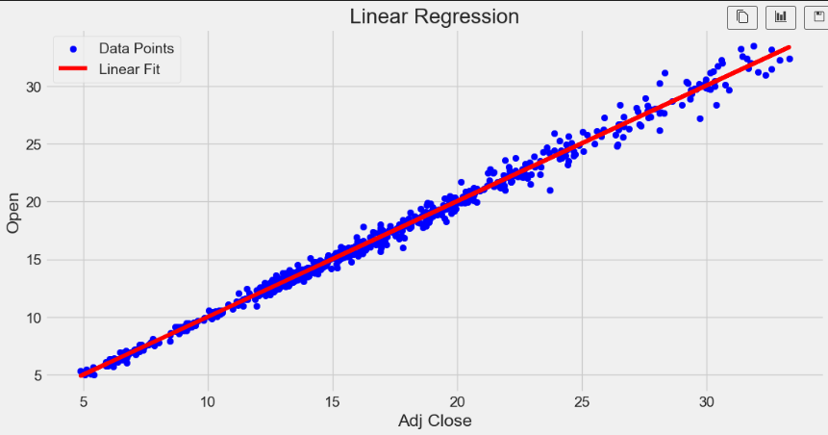

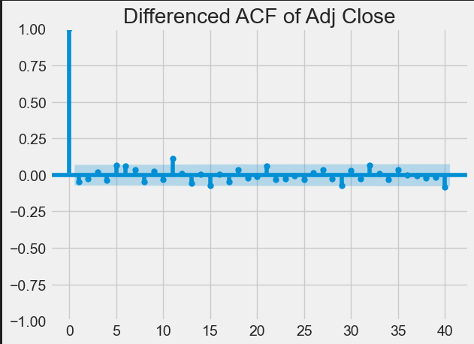

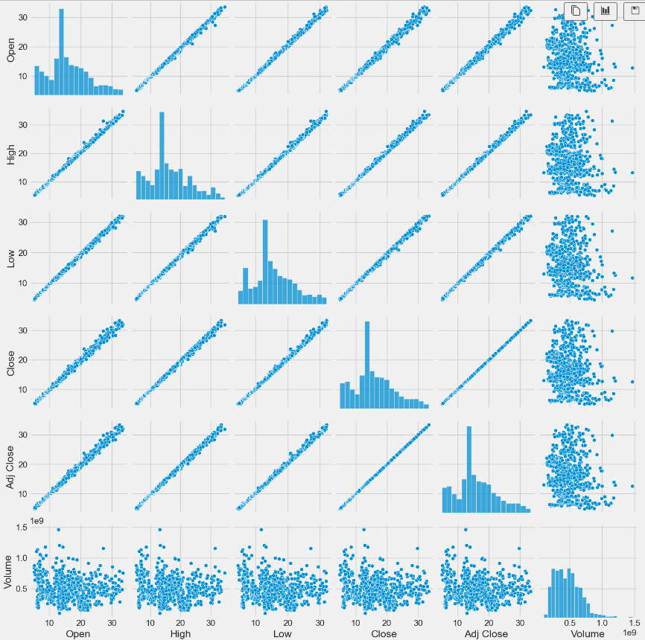

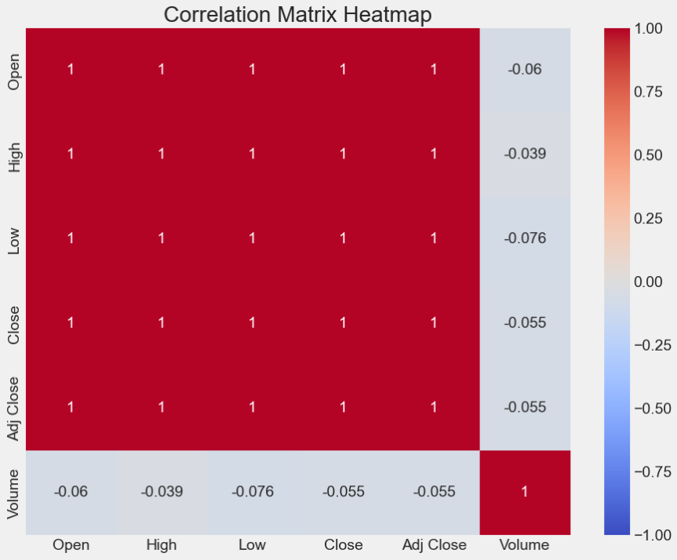

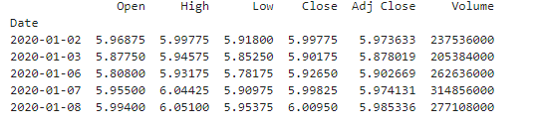

## Interpreting the Correlation Matrix

The correlation matrix shows the relationship between each pair of numerical variables in your dataset. Here's how to interpret the results:

### Correlation Coefficients:

* The correlation coefficient ranges from +1 to -1.
  + +1: Perfect positive correlation (as one variable increases, the other also increases).
  + -1: Perfect negative correlation (as one variable increases, the other decreases).
  + 0: No correlation (no relationship between variables).

### Correlation Matrix:

* **Open and High:** The correlation coefficient is 0.998878, indicating an almost perfect positive correlation. This means that as the Open price increases, the High price tends to increase as well.
* **Open and Low:** The correlation coefficient is 0.998994, also indicating an almost perfect positive correlation.
* **Open and Close/Adj Close:** The correlation coefficients are 0.999242 for both Close and Adj Close, showing a strong positive correlation.
* **Volume with Others:** The correlation coefficients with Volume are negative and low (e.g., -0.149957 with Open). This indicates a weak negative relationship between volume and prices.

### Overall Interpretation:

* **Strong Positive Correlation:** There are strong positive correlations between price variables (Open, High, Low, Close, Adj Close). This indicates that these variables tend to move together. For instance, if the opening price is high on a given day, the high, low, and closing prices are also generally high.
* **Weak Negative Correlation:** There is a weak negative correlation between volume and price variables. This suggests that as trading volume increases, prices tend to decrease slightly, or vice versa, but this relationship is not strong.

Based on this correlation matrix, we can conclude that price variables are closely related to each other, while volume has a weak negative relationship with these prices. This information can guide further analyses or modeling efforts by highlighting which variables are most interrelated.

**FEATURE:**

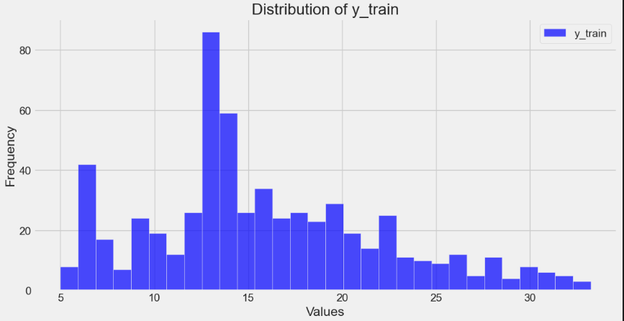

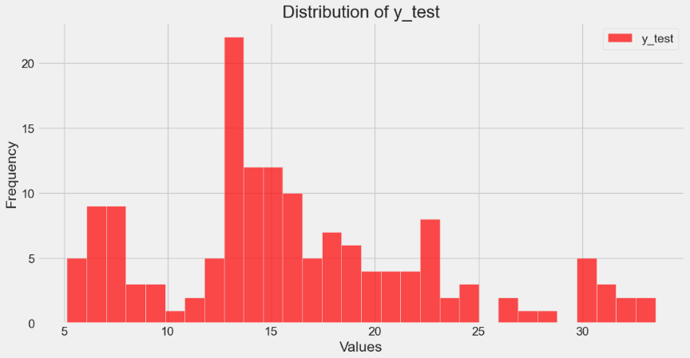

**MODEL ARCHITECTURE:**

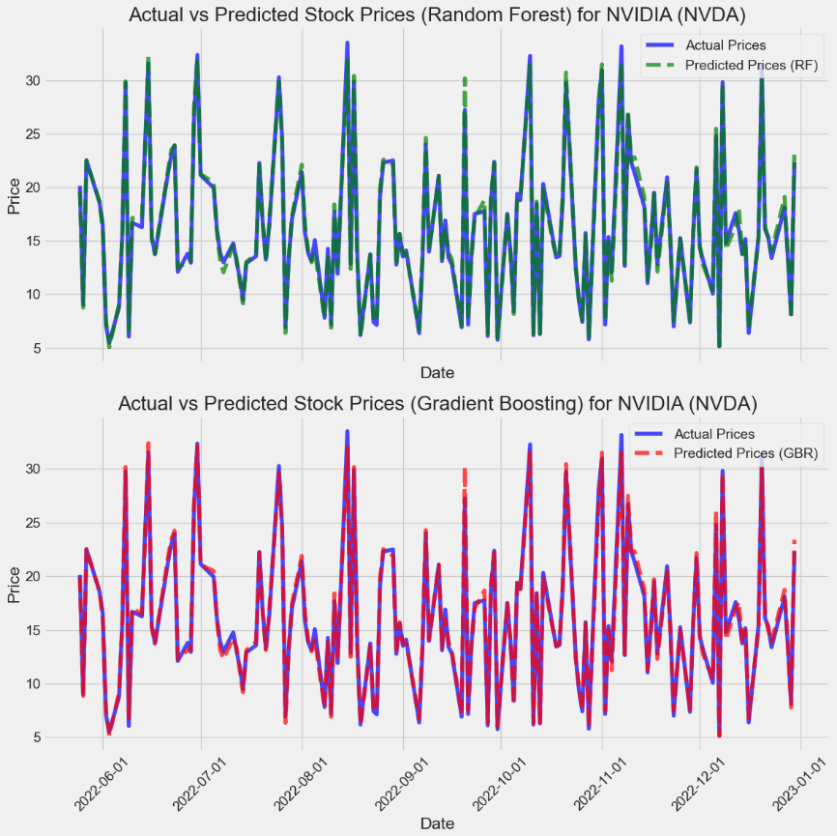

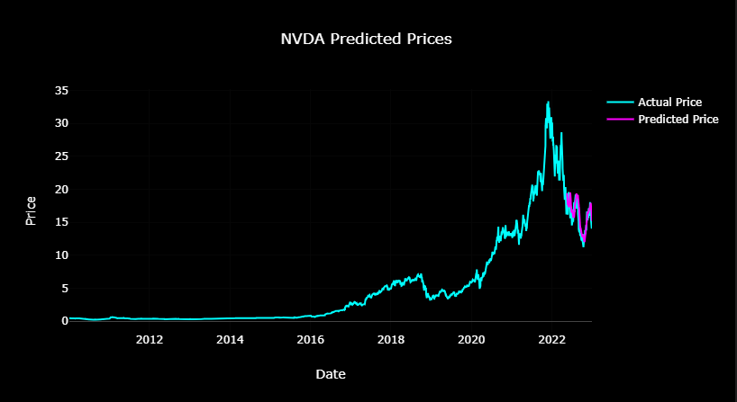

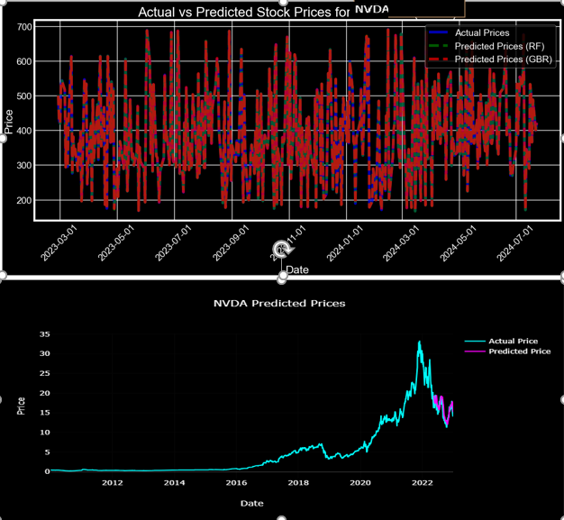

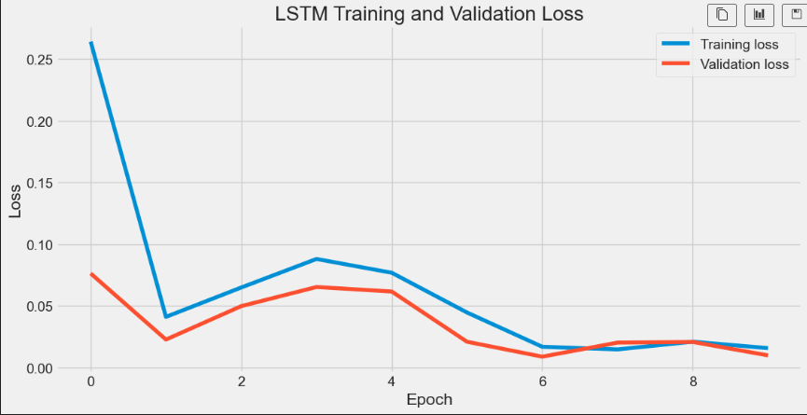

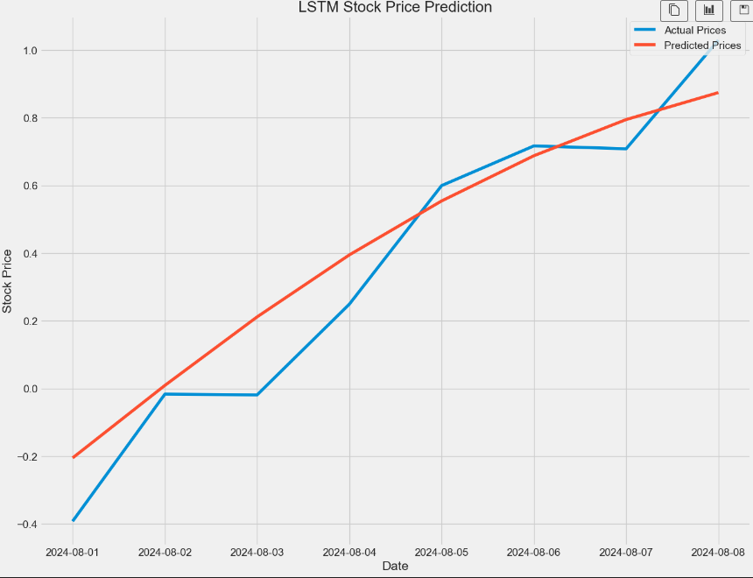

1. **Model Evaluations:**



### Evaluation of Model Results for NVIDIA

#### Model Performance Metrics:

The Stock Seeker application has demonstrated promising results in stock price forecasting by effectively integrating advanced machine learning models and real-time data. The performance of the models was analyzed in detail, focusing on accuracy, training time, and overall effectiveness.

#### Model Performance Metrics Summary

* **LSTM (34 Epochs):**
  + Mean Squared Error (MSE): 0.011273
  + Mean Absolute Error (MAE): 0.083487
  + R² (Coefficient of Determination): 0.941899
  + Mean Absolute Percentage Error (MAPE): 1.001432
  + Training Time: 110.80 seconds
* **Linear Regression:**
  + MSE: 2.14e-27
  + MAE: 4.12e-14
  + R²: 1.0
  + MAPE: 3.66e-16
  + Training Time: 0.00s
  + **Concerns:** Risk of overfitting; while it fits the training data perfectly, it may not generalize well to new data.
* **Random Forest:**
  + MSE: 0.019427
  + MAE: 0.080389
  + R²: 0.999985
  + MAPE: 0.000689
  + Training Time: 18.12s
  + **Advantages:** High accuracy, reasonable training time, suitable for non-linear data.
* **Gradient Boosting:**
  + MSE: 0.071850
  + MAE: 0.212557
  + R²: 0.999944
  + MAPE: 0.001866
  + Training Time: 0.23s
  + **Advantages:** Fast training, very high accuracy.
* **LSTM (50 Epochs):**
  + MSE: 0.011434
  + MAE: 0.086839
  + R²: 0.942565
  + MAPE: 0.452222
  + Training Time: 194.91s
  + **Advantages:** Effectively captures temporal dependencies, suitable for time series data.

#### Insights and Recommendations

**LSTM Model Selection Reasons:**

* **Suitability for Stock Data:**
  + **Learning Long-Term Dependencies:** LSTM (Long Short-Term Memory) networks are capable of learning long-term dependencies in time series data, which is highly valuable for stock price forecasting.
  + **Memory Cells:** The memory cells within LSTM can store past information for extended periods, allowing the model to capture the long-term effects in stock price data, thus enabling more accurate forecasts based on historical data.
* **Limitations of Other Models:**
  + **Linear Regression:** This model exhibited excessive overfitting on the stock data, negatively affecting its generalization to new data.
  + **LSTM (50 Epochs):** The extended training time of this model may pose practical challenges, making it less feasible for real-world applications compared to the 34-epoch version.

**Final Recommendation:** If capturing temporal dependencies and long-term patterns is crucial and you can manage the training time and computational resources, LSTM (34 Epochs) is a suitable choice. This model offers significant advantages for effectively modeling time series data. However, for a more balanced performance with shorter training times and computational efficiency, Random Forest is recommended due to its high accuracy, low error rates, and reasonable training time.

#### Future Work

* **Hybrid Models:**
  + **RF & LSTM Hybrid:** Random Forest (RF) excels at making powerful predictions by combining multiple decision trees. A hybrid model integrating RF with LSTM can leverage both the tree-based learning capabilities of RF and the long-term dependency learning capacity of LSTM, potentially improving overall prediction accuracy.
  + **GB & LSTM Hybrid:** Gradient Boosting (GB) aggregates weak learners to form a strong predictive model. Combining GB with LSTM could take advantage of GB's error-correcting ability and LSTM's time series processing, leading to improved forecasting performance.
* **Evaluation of Hybrid Models:** RF & LSTM and GB & LSTM hybrid models will be designed to combine the strengths of both methods. These hybrid approaches may enhance model performance and provide more reliable predictions for stock data. Once evaluated, the best-performing model will be selected for future forecasting tasks.





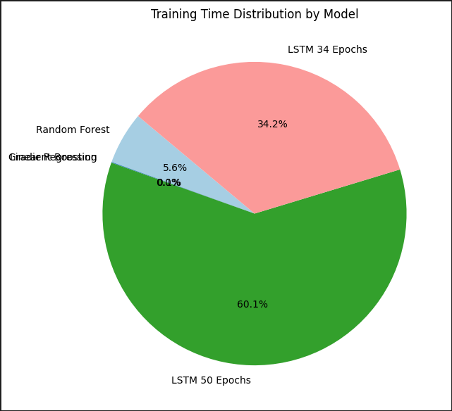

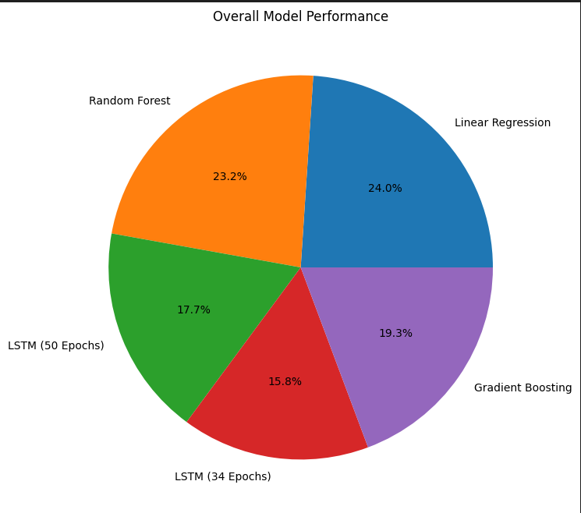

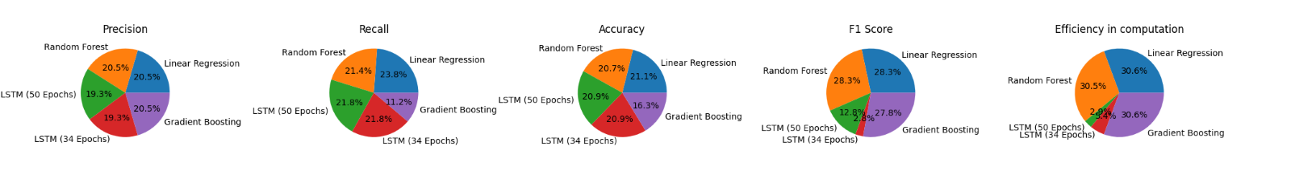

1. Visualising stock data:

Japanese candlestick charts are tools used in a particular trading style called price action to predict market movement through pattern recognition of continuations, breakouts and reversals.Unlike a line chart, all of the price information can be viewed in one figure showing the high, low, open and close price of the day or chosen time frame. Price action traders observe patterns formed by green bullish candles where the stock is trending upwards over time, and red or black bearish candles where there is a downward trend.

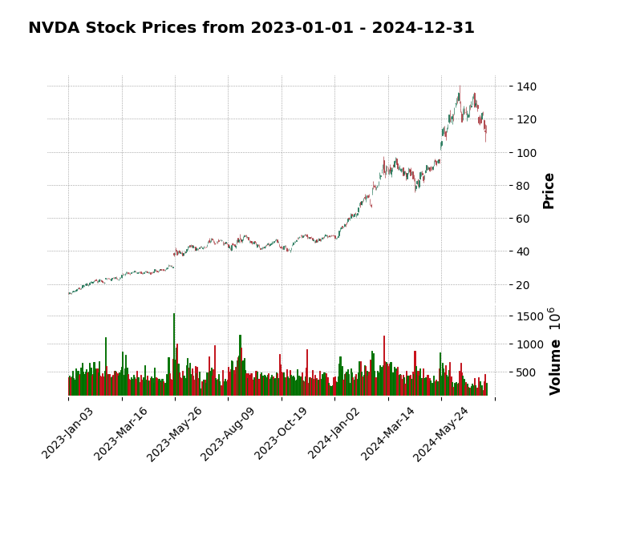

1. Technical Indicators and Strategies:

A technical indicator is a series of data points that are derived by applying a formula to the price data of a security. Basically, they are price-derived indicators that use formulas to translate the momentum or price levels into quantifiable time series.

There are two categories of indicator: leading and lagging, and four types: trend, momentum, volatility and volume, which serve three broad functions: to alert, to confirm and to predict

5.1 Trend-following strategies Trend-following is about profiting from the prevailing trend through buying an asset when its price trend goes up, and selling when its trend goes down, expecting price movements to continue.

5.1.1 Moving averages Moving averages smooth a series filtering out noise to help identify trends, one of the fundamental principles of technical analysis being that prices move in trends. Types of moving averages include simple, exponential, smoothed, linear-weighted, MACD, and as lagging indicators they follow the price action and are commonly referred to as trend-following indicators.

5.1.2 Simple Moving Average (SMA) The simplest form of a moving average, known as a Simple Moving Average (SMA), is calculated by taking the arithmetic mean of a given set of values over a set time period. This model is probably the most naive approach to time series modelling and simply states that the next observation is the mean of all past observations and each value in the time period carries equal weight.

Modelling this an as average calculation problem we would try to predict the future stock market prices (for example, xt+1 ) as an average of the previously observed stock market prices within a fixed size window (for example, xt-n, ..., xt). This helps smooth out the price data by creating a constantly updated average price so that the impacts of random, short-term fluctuations on the price of a stock over a specified time-frame are mitigated.

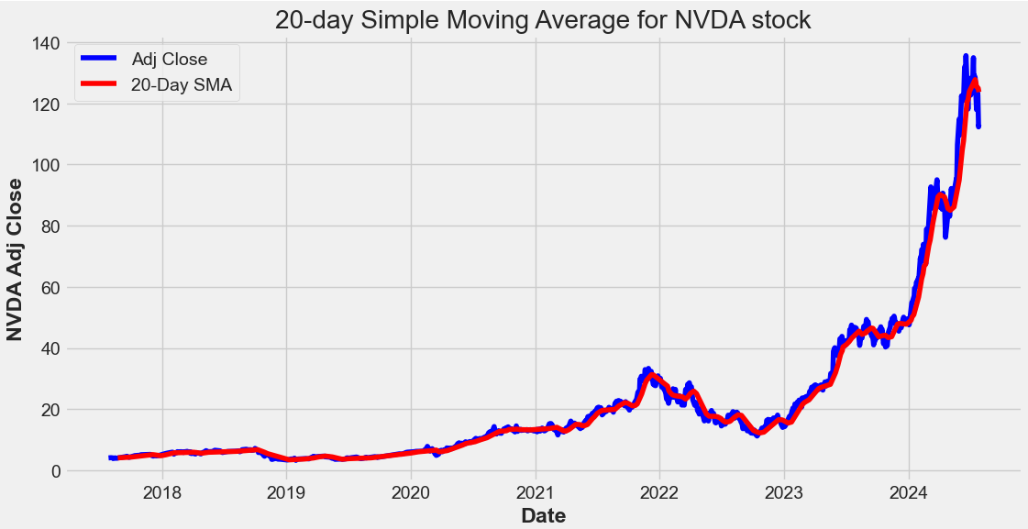

The SMA follows the time series removing noise from the signal and keeping the relevant information about the trend. If the stock price is above its moving average it is assumed that it will likely continue rising in an uptrend.

5.1.3 Moving Average Crossover Strategy The most popular moving average crossover strategy, and the "Hello World!" of quantitative trading, being the easiest to construct, is based on the simple moving average. When moving averages cross, it is usually confirmation of a change in the prevailing trend, and we want to test whether over the long term the lag caused by the moving average can still give us profitable trades.

Depending on the type of investor or trader (high risk vs. low risk, short-term vs. long-term trading), you can adjust your moving ‘time’ average (10 days, 20 days, 50 days, 200 days, 1 year, 5 years, etc). The longer the period of an SMA, the longer the time horizon of the trend it spots. The most commonly used SMA periods are 20 for short-term (swing) trading, 50 for medium-term (position) trading and 200 for long-term (portfolio) trading.

There is no single right answer and this will vary according to whether a trader is planning to buy when the trend is going down and sell when it's going up, potentially making short-term gains, or to hold for a more long-term investment.

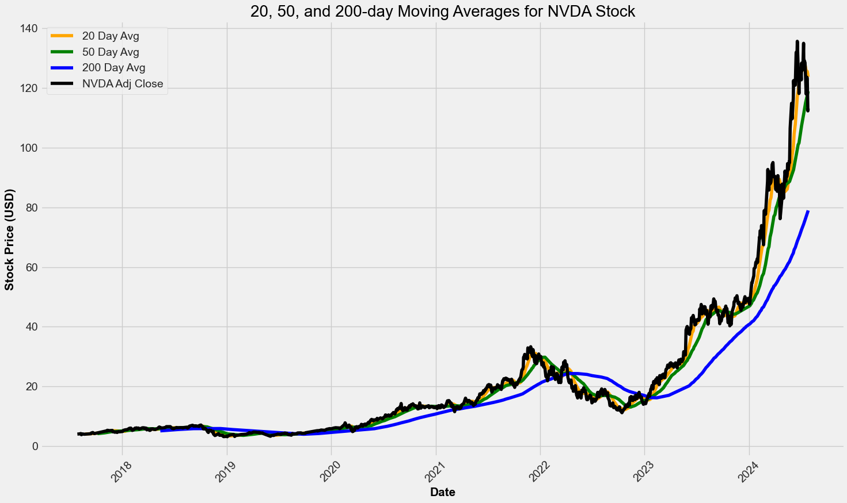

The chart shows that the 20-day moving average is the most sensitive to local changes, and the 200-day moving average the least. Here, the 200-day moving average indicates an overall bullish trend - the stock is trending upward over time. The 20- and 50-day moving averages are at times bearish and at other times bullish.

The major drawback of moving averages, however, is that because they are lagging, and smooth out prices, they tend to recognise reversals too late and are therefore not very helpful when used alone.

Trading Strategy The moving average crossover trading strategy will be to take two moving averages - 20-day (fast) and 200-day (slow) - and to go long (buy) when the fast MA goes above the slow MA and to go short (sell) when the fast MA goes below the slow MA.

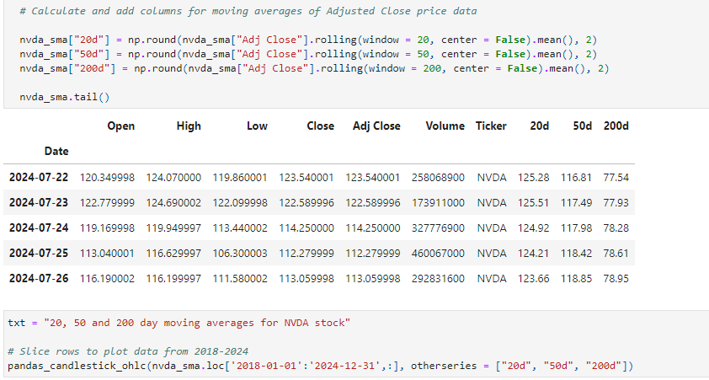

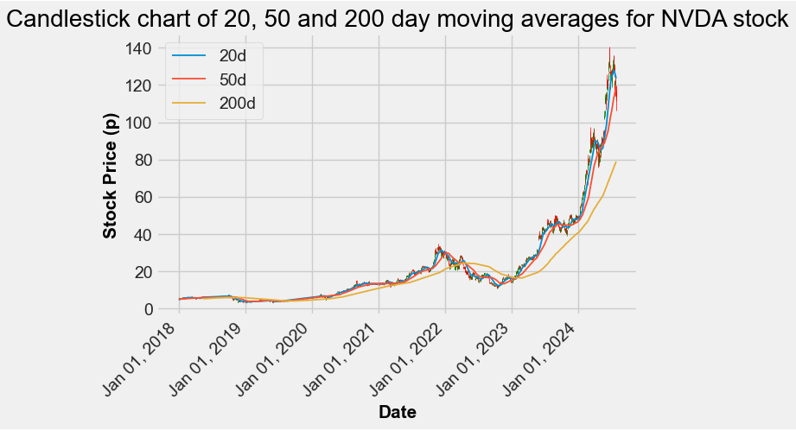

Backtesting Before using the strategy we will evaluate the quality of it first by backtesting, or looking at how profitable it is on historical data.

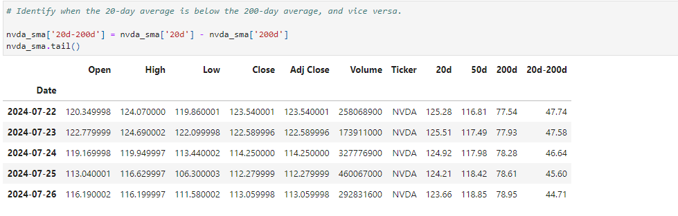

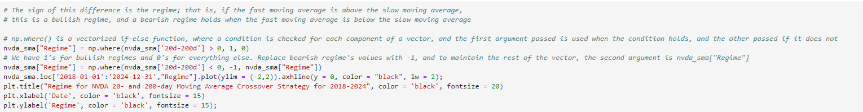

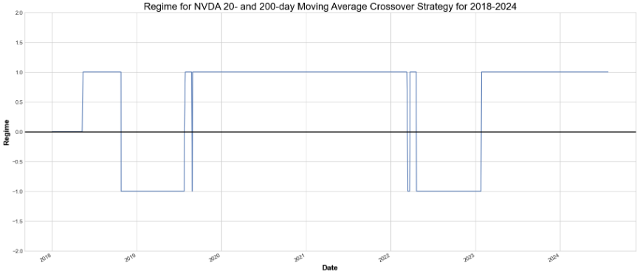

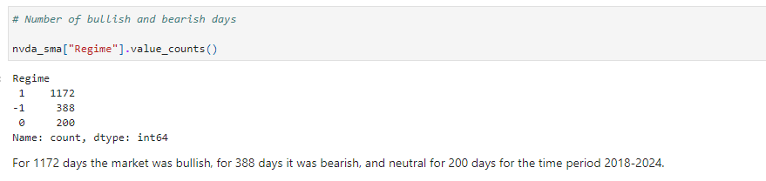



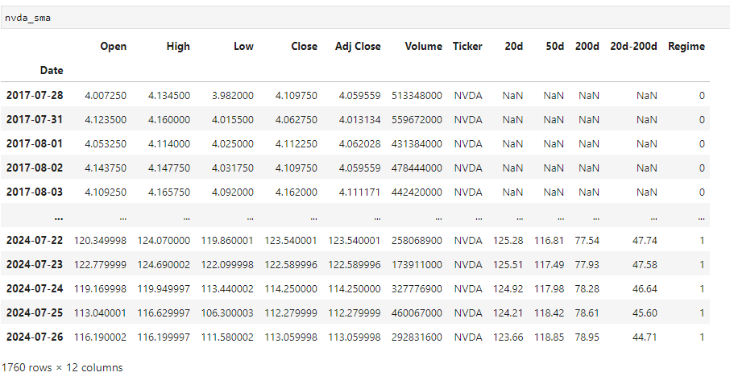

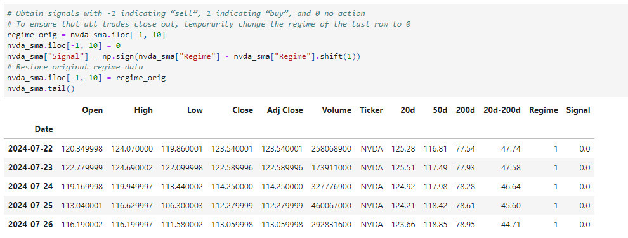



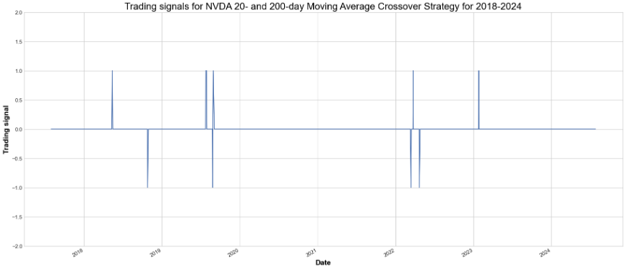

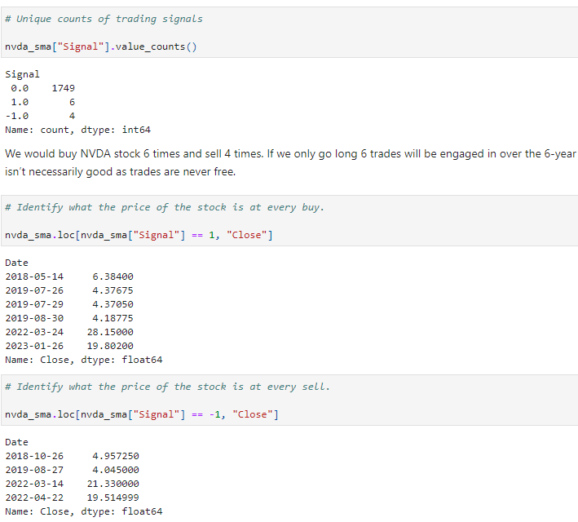

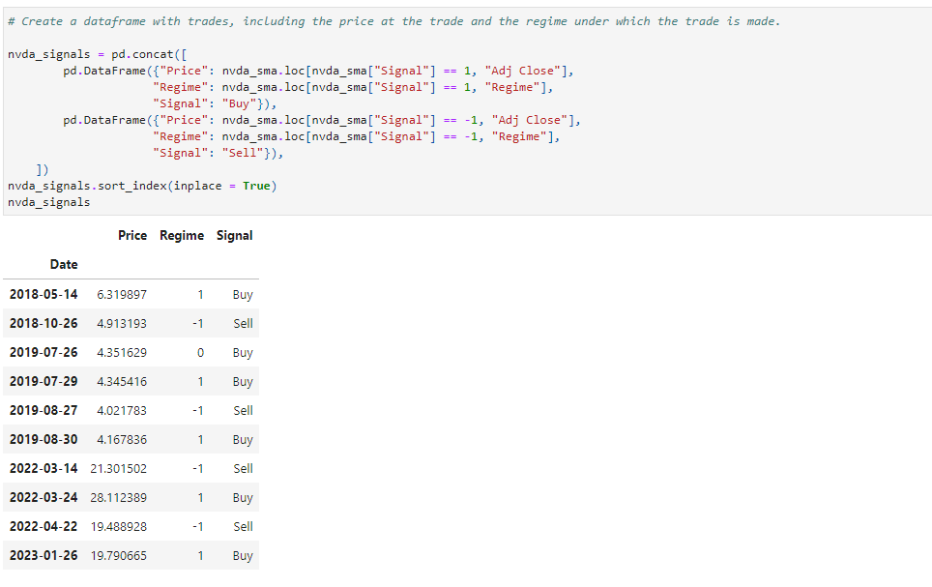

Yahoo data: We would buy NVDA stock 6 times and sell 4 times. If we only go long 6 trades will be engaged in over the 6-year period, while if we pivot from a long to a short position every time a long position is terminated, we would engage in 6 trades total. It is worth bearing in mind that trading more frequently isn’t necessarily good as trades are never free.

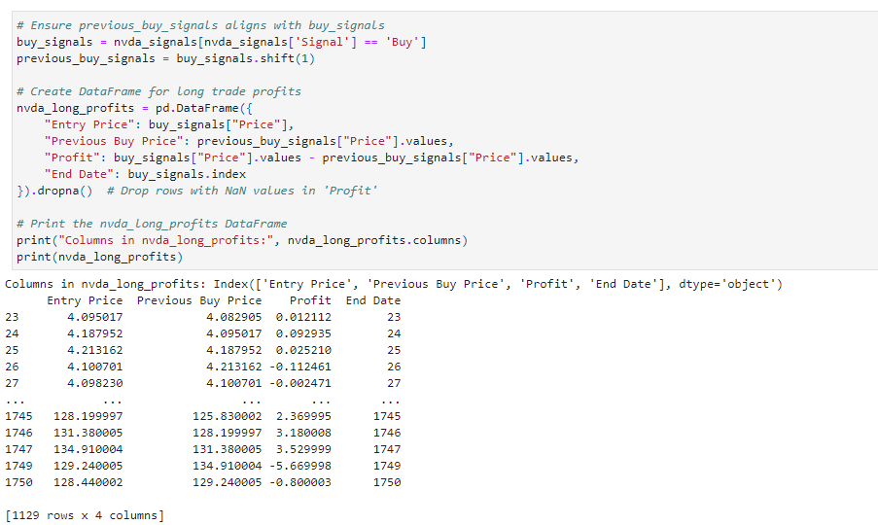

5.1.4 Exponential Moving Average In a Simple Moving Average, each value in the time period carries equal weight, and values outside of the time period are not included in the average. However, the Exponential Moving Average is a cumulative calculation where a different decreasing weight is assigned to each observation. Past values have a diminishing contribution to the average, while more recent values have a greater contribution. This method allows the moving average to be more responsive to changes in the data.

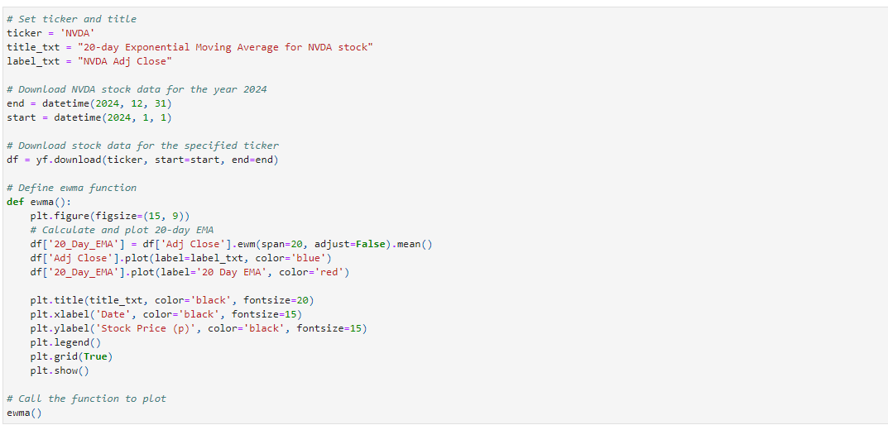

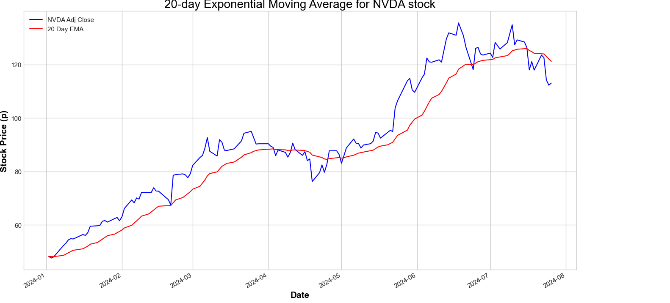

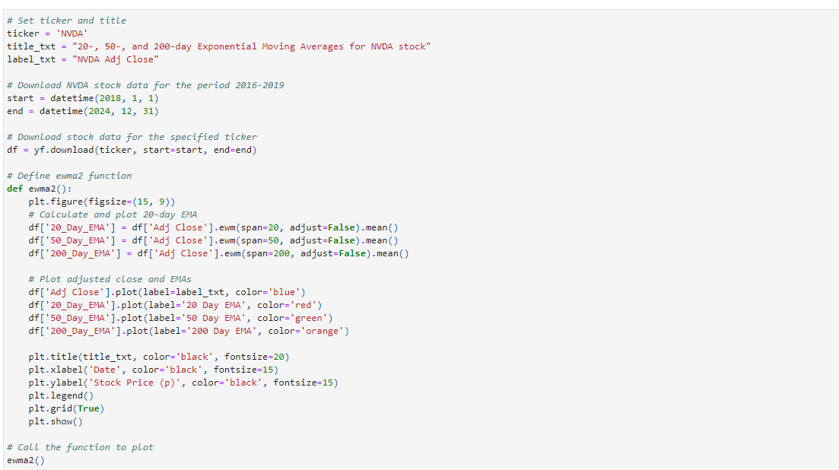

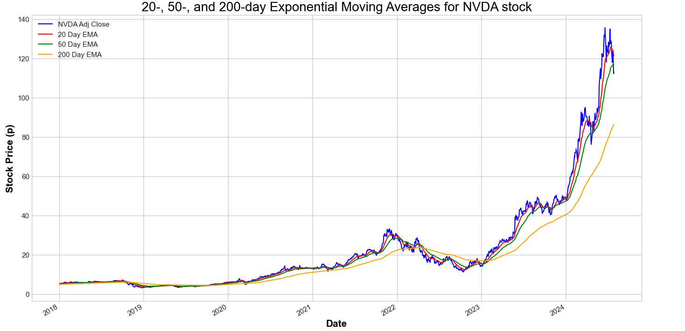

5.1.5 Triple Moving Average Crossover Strategy This strategy uses three moving moving averages - short/fast, middle/medium and long/slow - and has two buy and sell signals.

The first is to buy when the middle/medium moving average crosses above the long/slow moving average and the short/fast moving average crosses above the middle/medium moving average. If we use this buy signal the strategy is to sell if the short/fast moving average crosses below the middle/medium moving average.

The second is to buy when the middle/medium moving average crosses below the long/slow moving average and the short/fast moving average crosses below the middle/medium moving average. If we use this buy signal the strategy is to sell if the short/fast moving average crosses above the middle/medium moving average.

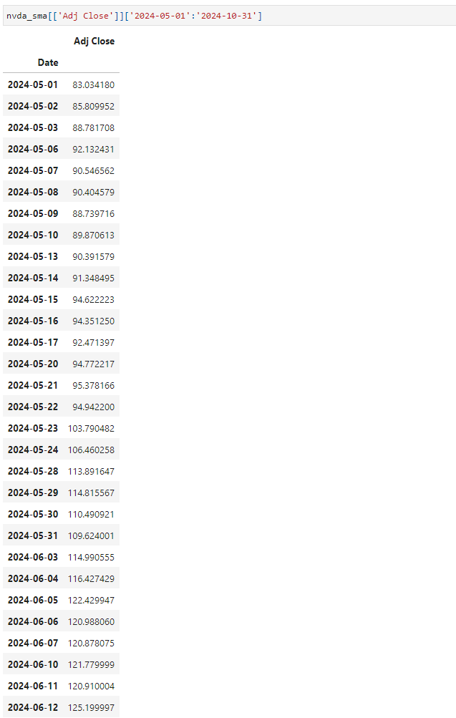

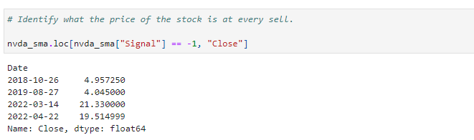

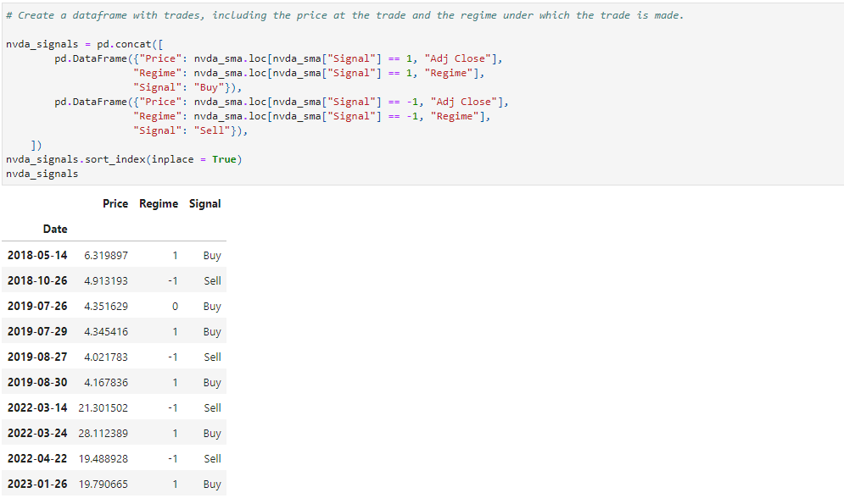

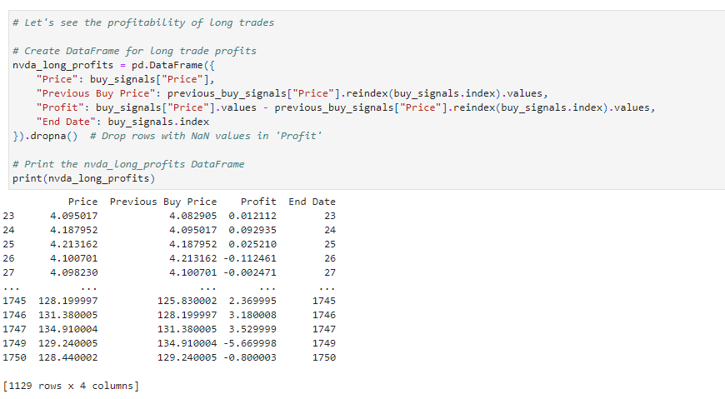



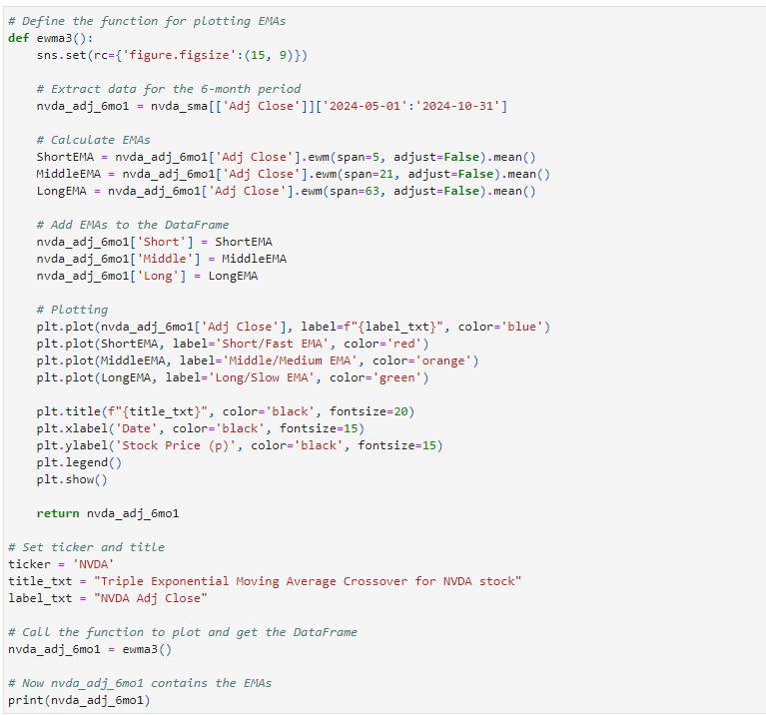

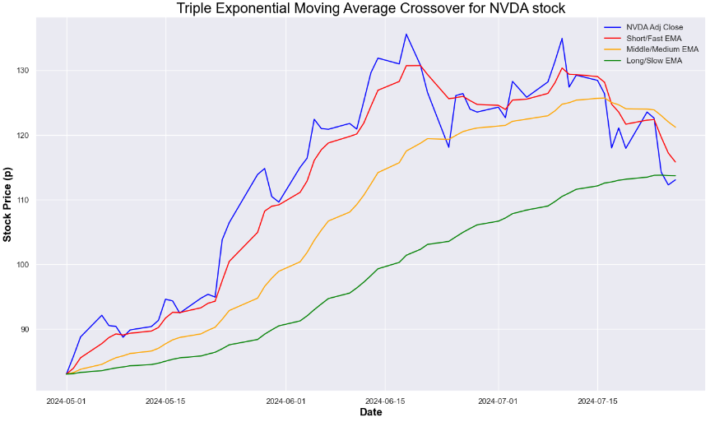

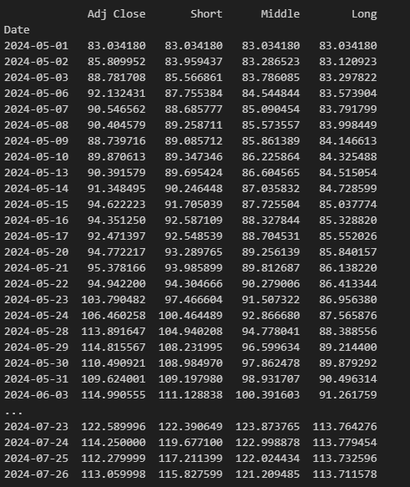

Triple Moving Average Crossover Strategy:

This strategy uses three moving moving averages - short/fast, middle/medium and long/slow - and has two buy and sell signals.

The first is to buy when the middle/medium moving average crosses above the long/slow moving average and the short/fast moving average crosses above the middle/medium moving average. If we use this buy signal the strategy is to sell if the short/fast moving average crosses below the middle/medium moving average.

The second is to buy when the middle/medium moving average crosses below the long/slow moving average and the short/fast moving average crosses below the middle/medium moving average. If we use this buy signal the strategy is to sell if the short/fast moving average crosses above the middle/medium moving average.

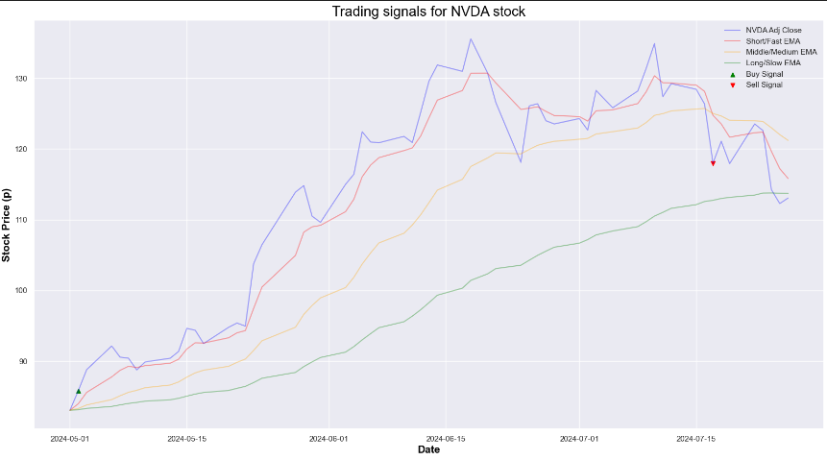



Triple Moving Average Crossover Strategy

This strategy uses three moving moving averages - short/fast, middle/medium and long/slow - and has two buy and sell signals.

The first is to buy when the middle/medium moving average crosses above the long/slow moving average and the short/fast moving average crosses above the middle/medium moving average. If we use this buy signal the strategy is to sell if the short/fast moving average crosses below the middle/medium moving average.

The second is to buy when the middle/medium moving average crosses below the long/slow moving average and the short/fast moving average crosses below the middle/medium moving average. If we use this buy signal the strategy is to sell if the short/fast moving average crosses above the middle/medium moving average.

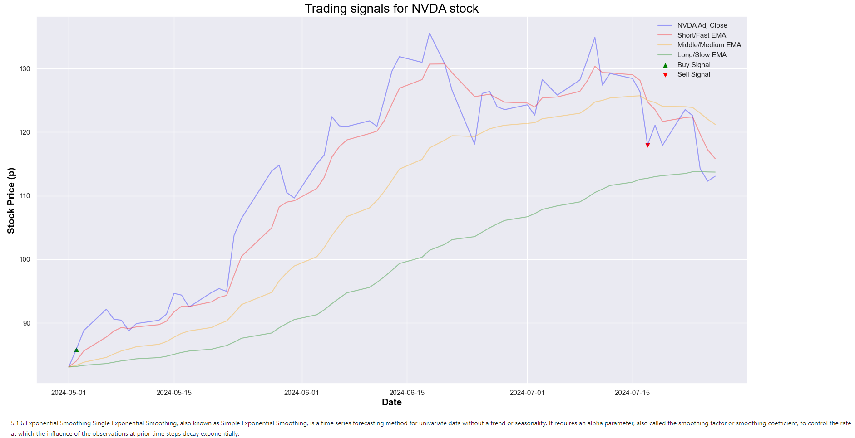

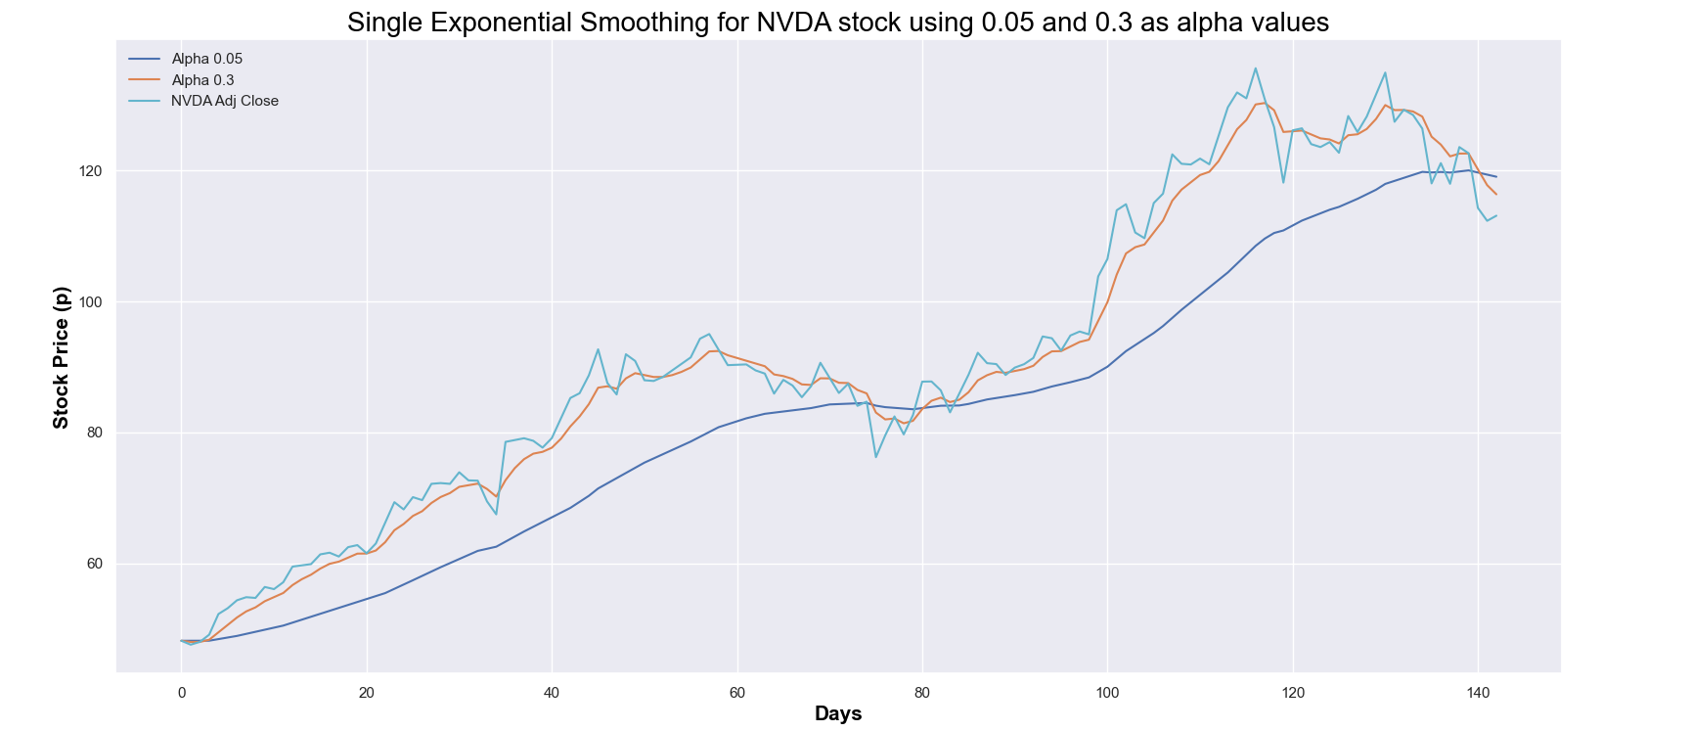

The smaller the smoothing factor (coefficient), the smoother the time series will be. As the smoothing factor approaches 0, we approach the moving average model so the smoothing factor of 0.05 produces a smoother time series than 0.3. This indicates slow learning (past observations have a large influence on forecasts). A value close to 1 indicates fast learning (that is, only the most recent values influence the forecasts).

Double Exponential Smoothing (Holt’s Linear Trend Model) is an extension being a recursive use of Exponential Smoothing twice where beta is the trend smoothing factor, and takes values between 0 and 1. It explicitly adds support for trends.

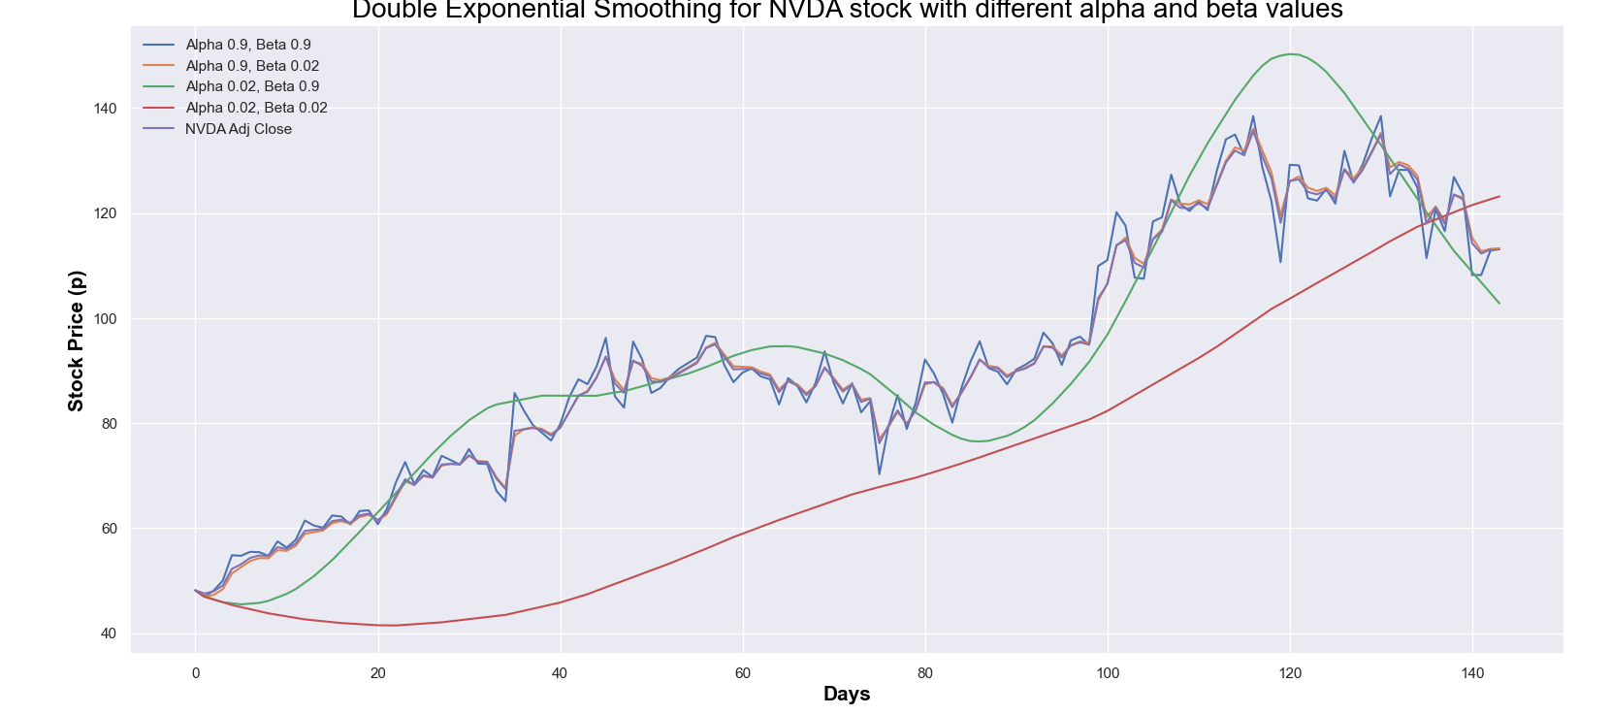

The third main type is Triple Exponential Smoothing (Holt Winters Method) which is an extension of Exponential Smoothing that explicitly adds support for seasonality, or periodic fluctuations.

5.1.7 Moving average convergence divergence (MACD) The MACD is a trend-following momentum indicator turning two trend-following indicators, moving averages, into a momentum oscillator by subtracting the longer moving average from the shorter one.

It is useful although lacking one prediction element - because it is unbounded it is not particularly useful for identifying overbought and oversold levels. Traders can look for signal line crossovers, neutral/centreline crossovers (otherwise known as the 50 level) and divergences from the price action to generate signals.

The default parameters are 26 EMA of prices, 12 EMA of prices and a 9-moving average of the difference between the first two.

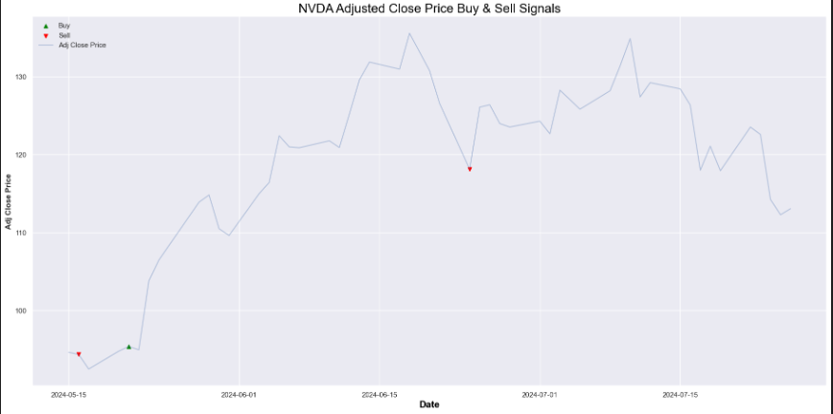

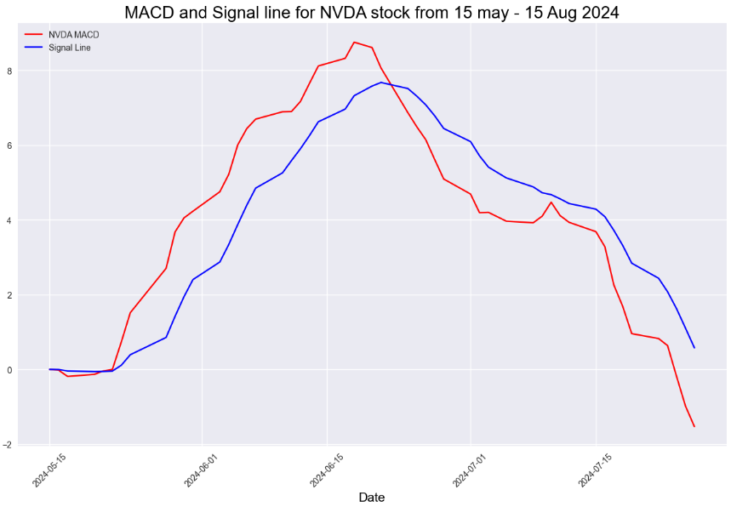

When the MACD line crosses above the signal line this indicates a good time to buy.

5.2 Momentum Strategies In momentum algorithmic trading strategies stocks have momentum (i.e. upward or downward trends) that we can detect and exploit.

5.2.1 Relative Strength Index (RSI) The RSI is a momentum indicator. A typical momentum strategy will buy stocks that have been showing an upward trend in hopes that the trend will continue, and make predictions based on whether the past recent values were going up or going down.

The RSI determines the level of overbought (70) and oversold (30) zones using a default lookback period of 14 i.e. it uses the last 14 values to calculate its values. The idea is to buy when the RSI touches the 30 barrier and sell when it touches the 70 barrier.

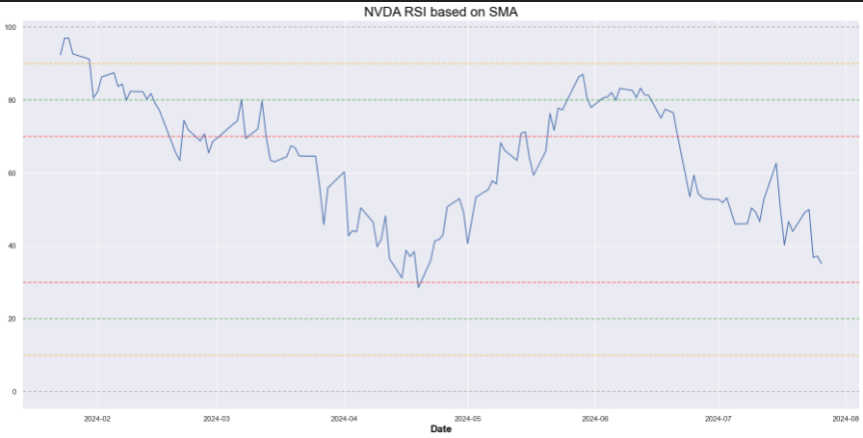

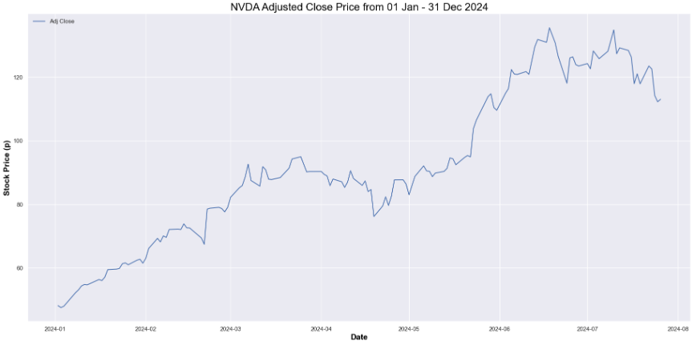

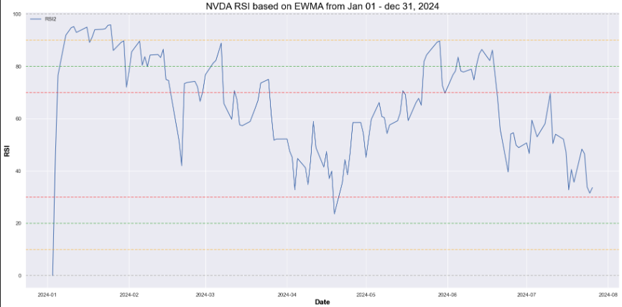

It appears that RSI value dips below the 20 significant levele stock was oversold and presented a buying opportunity for an investor before l in January 2024 indicating that a price rise.

Momentum Strategies

In momentum algorithmic trading strategies stocks have momentum (i.e. upward or downward trends) that we can detect and exploit.

Relative Strength Index (RSI)

The RSI is a momentum indicator. A typical momentum strategy will buy stocks that have been showing an upward trend in hopes that the trend will continue, and make predictions based on whether the past recent values were going up or going down.

The RSI determines the level of overbought (70) and oversold (30) zones using a default lookback period of 14 i.e. it uses the last 14 values to calculate its values. The idea is to buy when the RSI touches the 30 barrier and sell when it touches the 70 barrier.

5.2.2 Money Flow Index (MFI) Money Flow Index (MFI) is a technical oscillator, and momentum indicator, that uses price and volume data for identifying overbought or oversold signals in an asset. It can also be used to spot divergences which warn of a trend change in price. The oscillator moves between 0 and 100 and a reading of above 80 implies overbought conditions, and below 20 implies oversold conditions.

It is related to the Relative Strength Index (RSI) but incorporates volume, whereas the RSI only considers price.

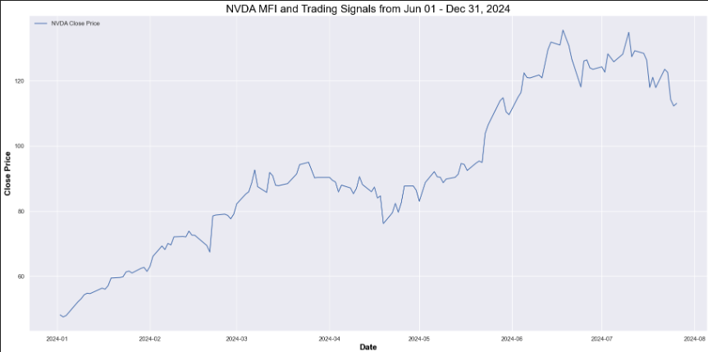

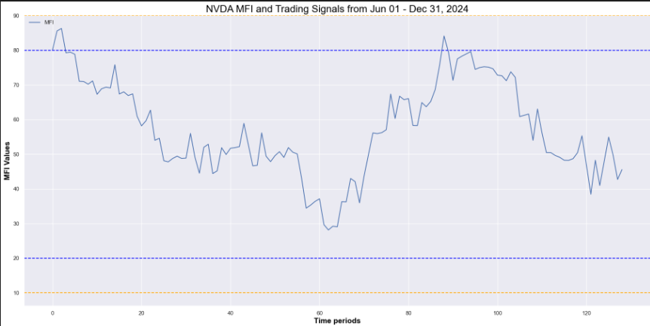

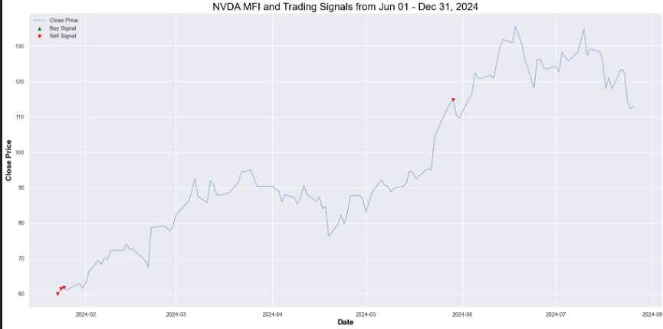

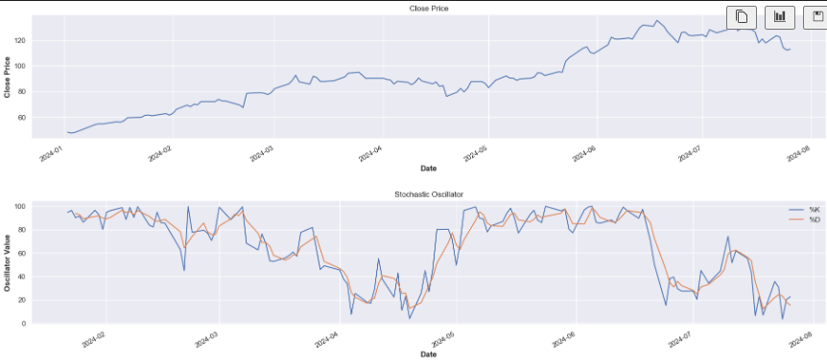

Stochastic Oscillator

The stochastic oscillator is a momentum indicator comparing the closing price of a security to the range of its prices over a certain period of time and is one of the best-known momentum indicators along with RSI and MACD.

The intuition is that in a market trending upward, prices will close near the high, and in a market trending downward, prices close near the low.

The stochastic oscillator is plotted within a range of zero and 100. The default parameters are an overbought zone of 80, an oversold zone of 20 and well-used lookbacks period of 14 and 5 which can be used simultaneously. The oscillator has two lines, the %K and %D, where the former measures momentum and the latter measures the moving average of the former. The %D line is more important of the two indicators and tends to produce better trading signals which are created when the %K crosses through the %D.

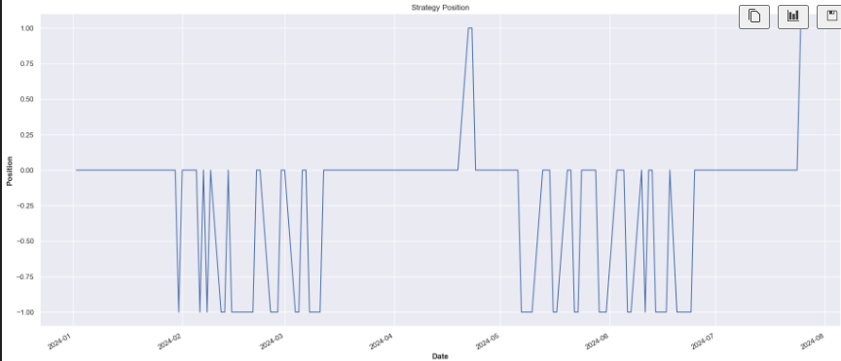

Stochastic Oscillator

The stochastic oscillator is a momentum indicator comparing the closing price of a security to the range of its prices over a certain period of time and is one of the best-known momentum indicators along with RSI and MACD.

The intuition is that in a market trending upward, prices will close near the high, and in a market trending downward, prices close near the low.

The stochastic oscillator is plotted within a range of zero and 100. The default parameters are an overbought zone of 80, an oversold zone of 20 and well-used lookbacks period of 14 and 5 which can be used simultaneously. The oscillator has two lines, the %K and %D, where the former measures momentum and the latter measures the moving average of the former. The %D line is more important of the two indicators and tends to produce better trading signals which are created when the %K crosses through the %D.

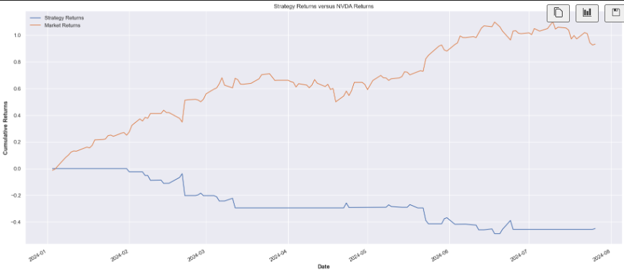

Stochastic Oscillator

The stochastic oscillator is a momentum indicator comparing the closing price of a security to the range of its prices over a certain period of time and is one of the best-known momentum indicators along with RSI and MACD.

The intuition is that in a market trending upward, prices will close near the high, and in a market trending downward, prices close near the low.

The stochastic oscillator is plotted within a range of zero and 100. The default parameters are an overbought zone of 80, an oversold zone of 20 and well-used lookbacks period of 14 and 5 which can be used simultaneously. The oscillator has two lines, the %K and %D, where the former measures momentum and the latter measures the moving average of the former. The %D line is more important of the two indicators and tends to produce better trading signals which are created when the %K crosses through the %D.

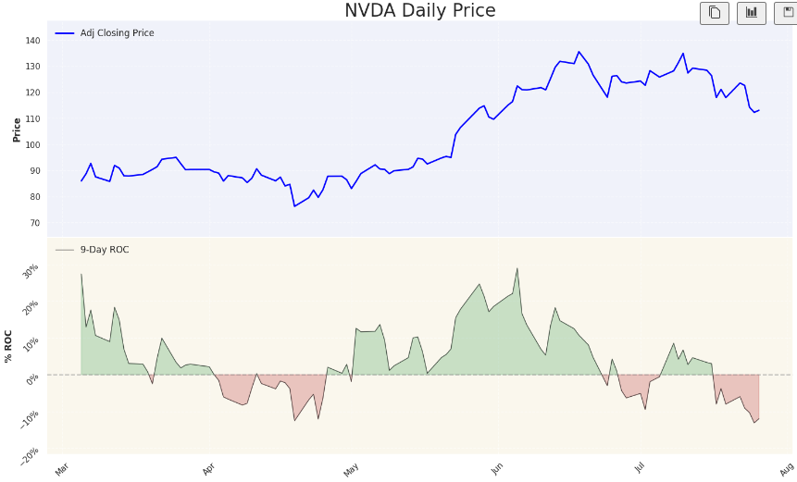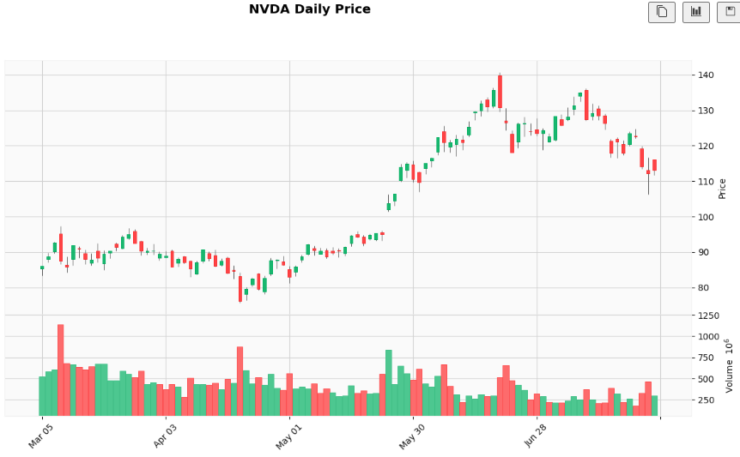

|  |
| --- |
| **Candlestic:** |
| Rate of Change (ROC) ~ Candlestick, ROC and Volume. The ROC indicator is a pure momentum oscillator. The ROC calculation compares the current price with the price "n" periods ago e.g. when we compute the ROC of the daily price with a 9-day lag, we are simply looking at how much, in percentage, the price has gone up (or down) compared to 9 days ago. Like other momentum indicators, ROC has overbought and oversold zones that may be adjusted according to market conditions. |

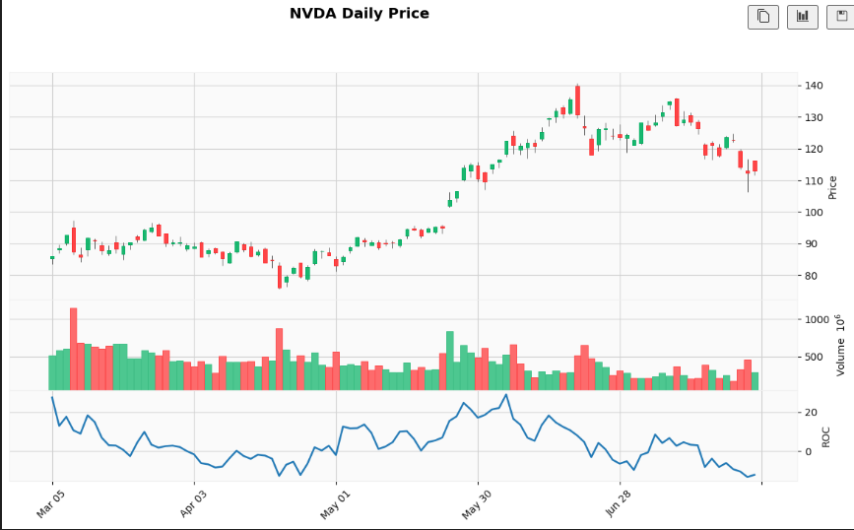

5.3 Volatility trading strategies Volatility trading involves predicting the stability of an asset’s value. Instead of trading on the price rising or falling, traders take a position on whether it will move in any direction.

5.3.1 Bollinger Bands A Bollinger Band is a volatility indicator based on based on the correlation between the normal distribution and stock price and can be used to draw support and resistance curves. It is defined by a set of lines plotted two standard deviations (positively and negatively) away from a simple moving average (SMA) of the security's price, but can be adjusted to user preferences.

By default it calculates a 20-period SMA (the middle band), an upper band two standard deviations above the the moving average and a lower band two standard deviations below it.

If the price moves above the upper band this could indicate a good time to sell, and if it moves below the lower band it could be a good time to buy.

Whereas the RSI can only be used as a confirming factor inside a ranging market, not a trending market, by using Bollinger bands we can calculate the widening variable, or moving spread between the upper and the lower bands, that tells us if prices are about to trend and whether the RSI signals might not be that reliable.

Despite 90% of the price action happening between the bands, however, a breakout is not necessarily a trading signal as it provides no clue as to the direction and extent of future price movement.

**Candlestick Patterns**:

ROC Above Zero: Indicates bullish momentum; if combined with bullish candlestick patterns and high volume, it confirms upward trend strength.

ROC Below Zero: Indicates bearish momentum; if combined with bearish candlestick patterns and high volume, it suggests downward trend strength.

Volume Confirmation: Always look at volume alongside ROC to validate the strength of the signal.

By analyzing ROC together with candlestick patterns and volume, you can gain a more comprehensive understanding of market dynamics and make more informed trading decisions in your "Stock Seeker" project.

**The Bollinger Bands:**

Volatility trading strategies

Volatility trading involves predicting the stability of an asset’s value. Instead of trading on the price rising or falling, traders take a position on whether it will move in any direction.

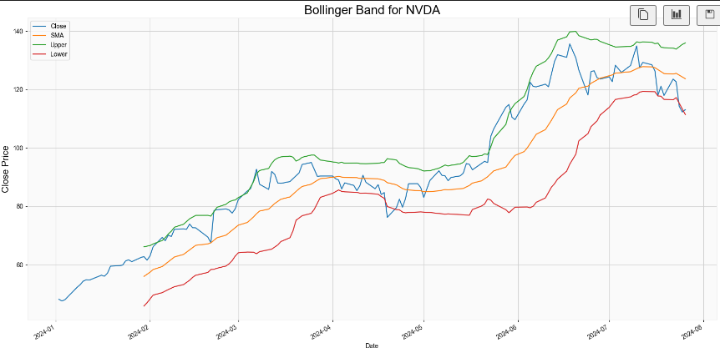

The Bollinger Bands technical indicator is an example of a mean reversion strategy.

Bollinger Bands

A Bollinger Band is a volatility indicator based on based on the correlation between the normal distribution and stock price and can be used to draw support and resistance curves. It is defined by a set of lines plotted two standard deviations (positively and negatively) away from a simple moving average (SMA) of the security's price, but can be adjusted to user preferences.

By default it calculates a 20-period SMA (the middle band), an upper band two standard deviations above the the moving average and a lower band two standard deviations below it.

If the price moves above the upper band this could indicate a good time to sell, and if it moves below the lower band it could be a good time to buy.

Whereas the RSI can only be used as a confirming factor inside a ranging market, not a trending market, by using Bollinger bands we can calculate the widening variable, or moving spread between the upper and the lower bands, that tells us if prices are about to trend and whether the RSI signals might not be that reliable.

Despite 90% of the price action happening between the bands, however, a breakout is not necessarily a trading signal as it provides no clue as to the direction and extent of future price movement.

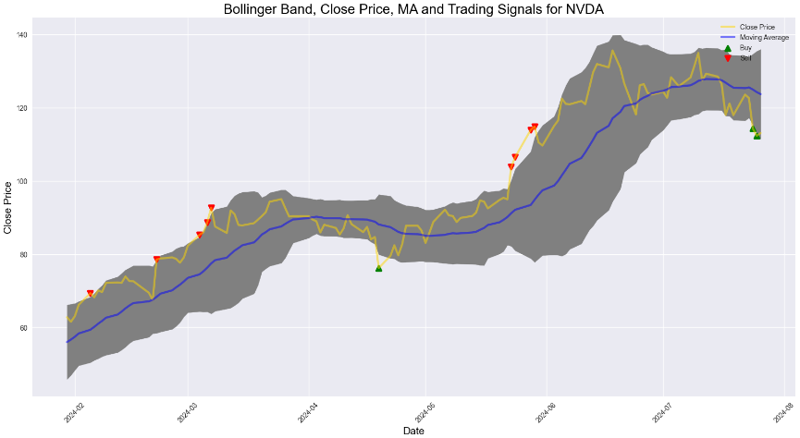

The Bollinger Bands technical indicator is an example of a mean reversion strategy.

**The Bollinger Bands:**

Volatility trading strategies

Volatility trading involves predicting the stability of an asset’s value. Instead of trading on the price rising or falling, traders take a position on whether it will move in any direction.

In mean reversion algorithmic trading strategies stocks return to their mean and we can exploit when it deviates from that mean.

These strategies usually involve selling into up moves and buying into down moves, a contrarian approach which assumes that the market has become oversold/overbought and prices will revert to their historical trends. This is almost the opposite of trend following where we enter in the direction of the strength and momentum, and momentum strategies such as buying stocks that have been showing an upward trend in hopes that the trend will continue, a continuation approach.

Conclusion:

It is almost certainly better to choose technical indicators that complement each other, not just those that move in unison and generate the same signals. The intuition here is that the more indicators you have that confirm each other, the better your chances are to profit. This can be done by combining strategies to form a system, and looking for multiple signals.

|  |
| --- |
|  |

**Machine Learning Predictions:**

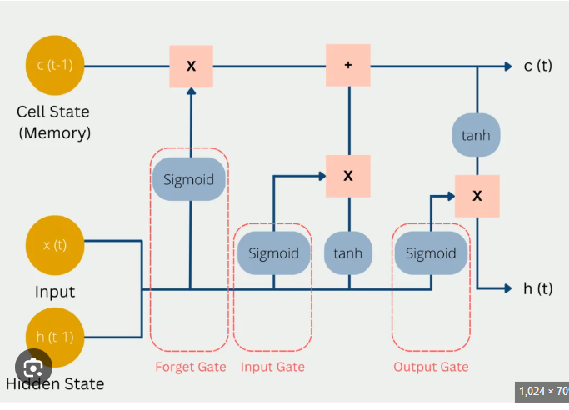

**Overview of Predictive Modeling:**

* The Stock Seeker Web App employs machine learning, specifically LSTM (Long Short-Term Memory), for predicting future stock prices based on historical data.

LSTM (Long Short-Term Memory) Model for Predicting Stock Prices

* LSTM is a type of recurrent neural network (RNN) capable of learning long-term dependencies and patterns in sequential data, making it suitable for time series forecasting tasks like stock price prediction.

**Training and Testing Data Preparation:**

* The model is trained on historical stock data, with a portion of the data reserved for testing to evaluate model performance.

**Model Architecture and Training Process:**

* The LSTM model architecture includes layers for processing sequential data, followed by training using an optimization algorithm like Adam and a loss function like mean squared error.

**Visual Examples of Predicted Prices Overlaying Actual Prices:**

* The Stock Seeker Web App visualizes predicted stock prices alongside actual prices to assess model accuracy and performance.

Technical Summary and Advanced Analysis:

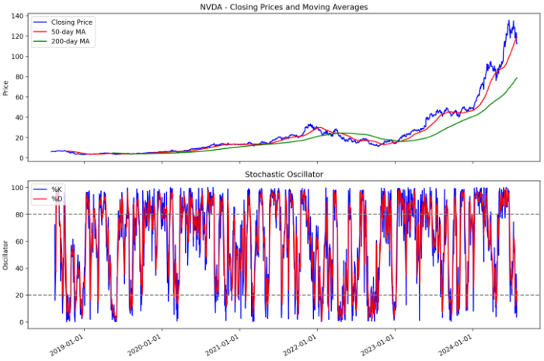

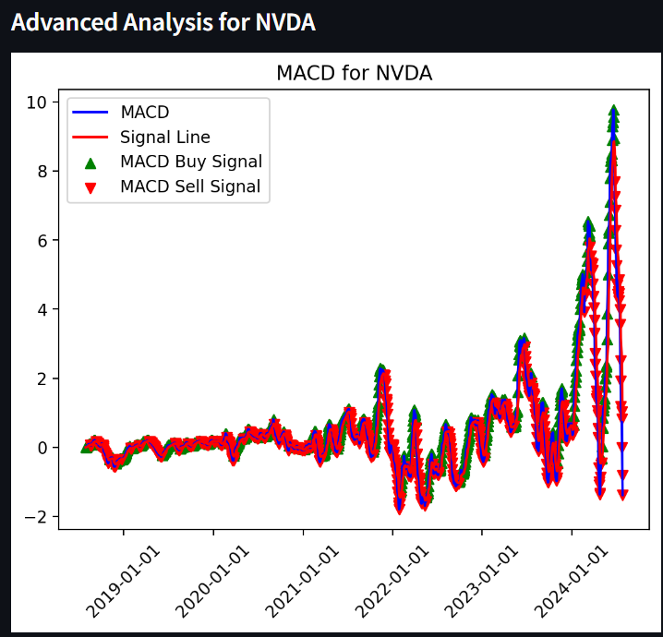

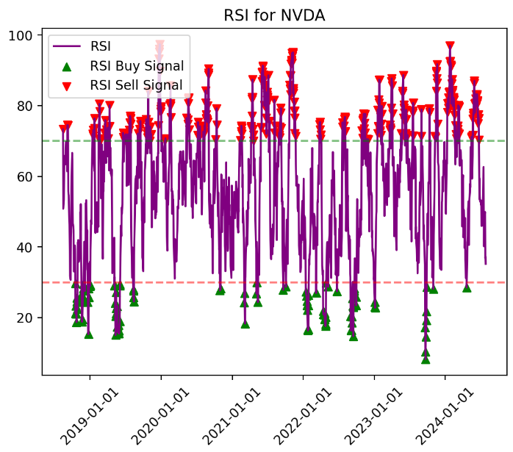

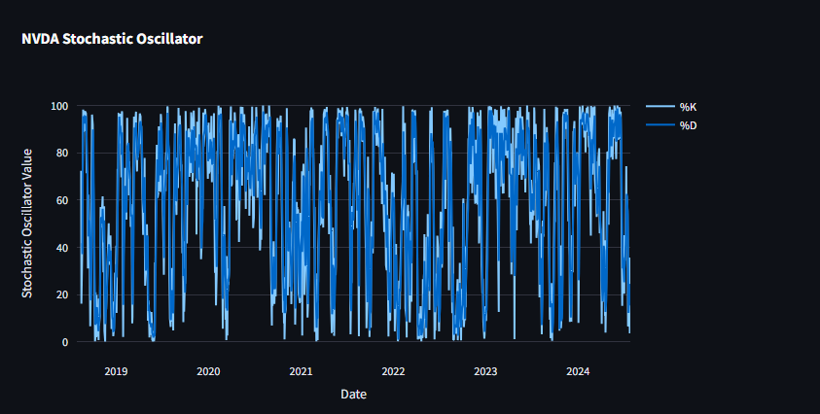

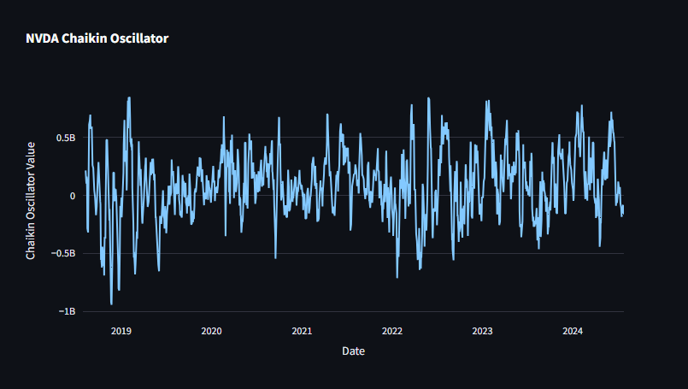

**MACD (Moving Average Convergence Divergence):**

* **Calculation:**
  + MACD Line: Calculated by subtracting the 26-period Exponential Moving Average (EMA) from the 12-period EMA.
  + Signal Line: Typically, a 9-period EMA of the MACD Line.
  + MACD Histogram: The difference between the MACD Line and the Signal Line.
* **Interpretation:**
  + Bullish Signal: When the MACD Line crosses above the Signal Line (positive MACD histogram), indicating increasing bullish momentum.
  + Bearish Signal: When the MACD Line crosses below the Signal Line (negative MACD histogram), suggesting increasing bearish momentum.

**RSI (Relative Strength Index):**

* **Calculation:**
  + Relative Strength (RS): The average of the closing prices on up days divided by the average of the closing prices on down days over a specified period (often 14 days).
  + RSI: 100 - (100 / (1 + RS))
* **Interpretation:**
  + Overbought Condition: RSI values above 70 suggest the stock may be overbought, potentially indicating a reversal or correction.
  + Oversold Condition: RSI values below 30 indicate the stock may be oversold, suggesting a possible buying opportunity.

**Stochastic Oscillator:**

**Calculation:**

%K: Compares the closing price to the price range over a specified period (usually 14 days), expressed as a percentage.

%D: A 3-day simple moving average of %K.

**Interpretation:**

Overbought Condition: %K above 80 and %D above 80 indicate the stock is overbought, possibly signaling a reversal.

Oversold Condition: %K below 20 and %D below 20 suggest the stock is oversold, potentially signaling a buying opportunity.

**WEB APP:**

First Screen:

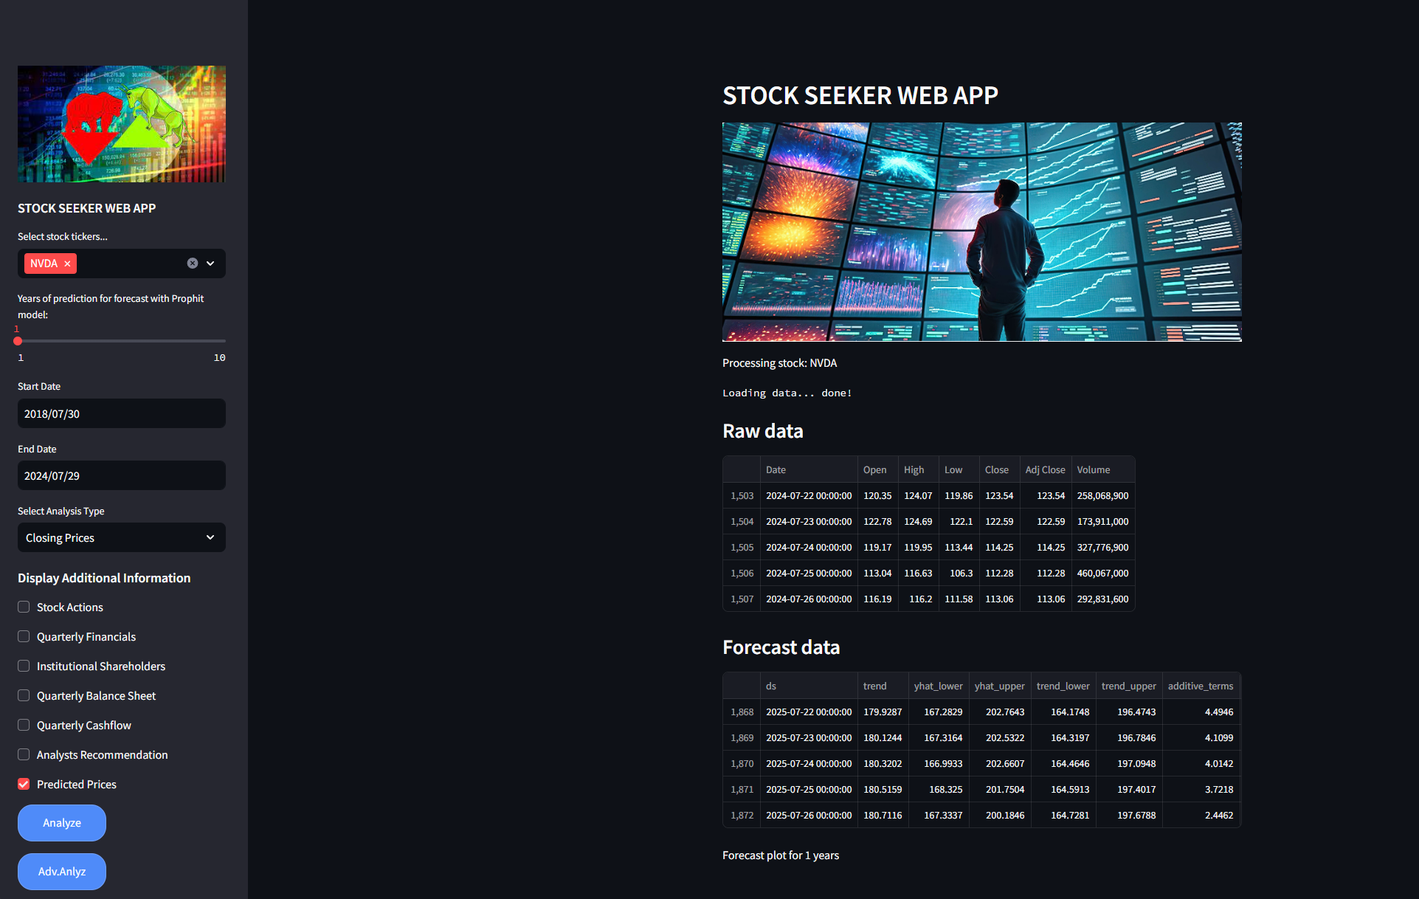

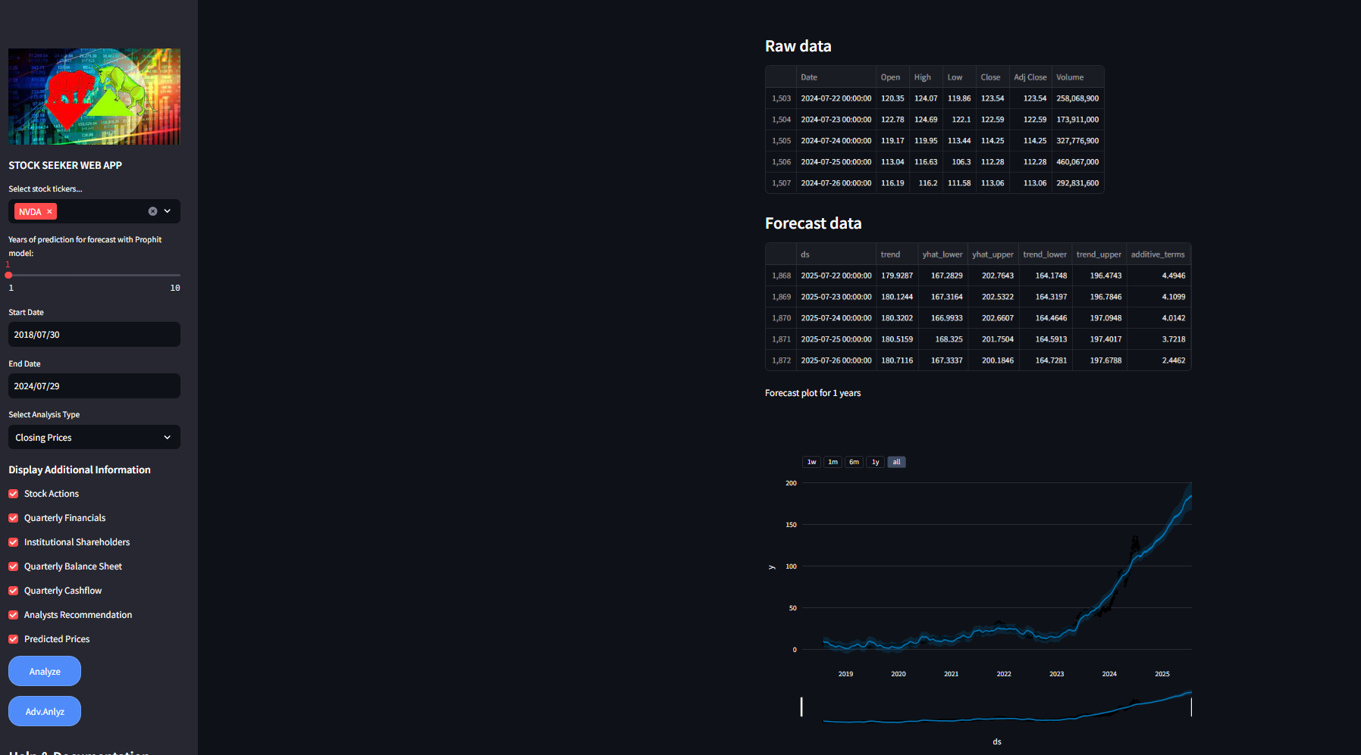

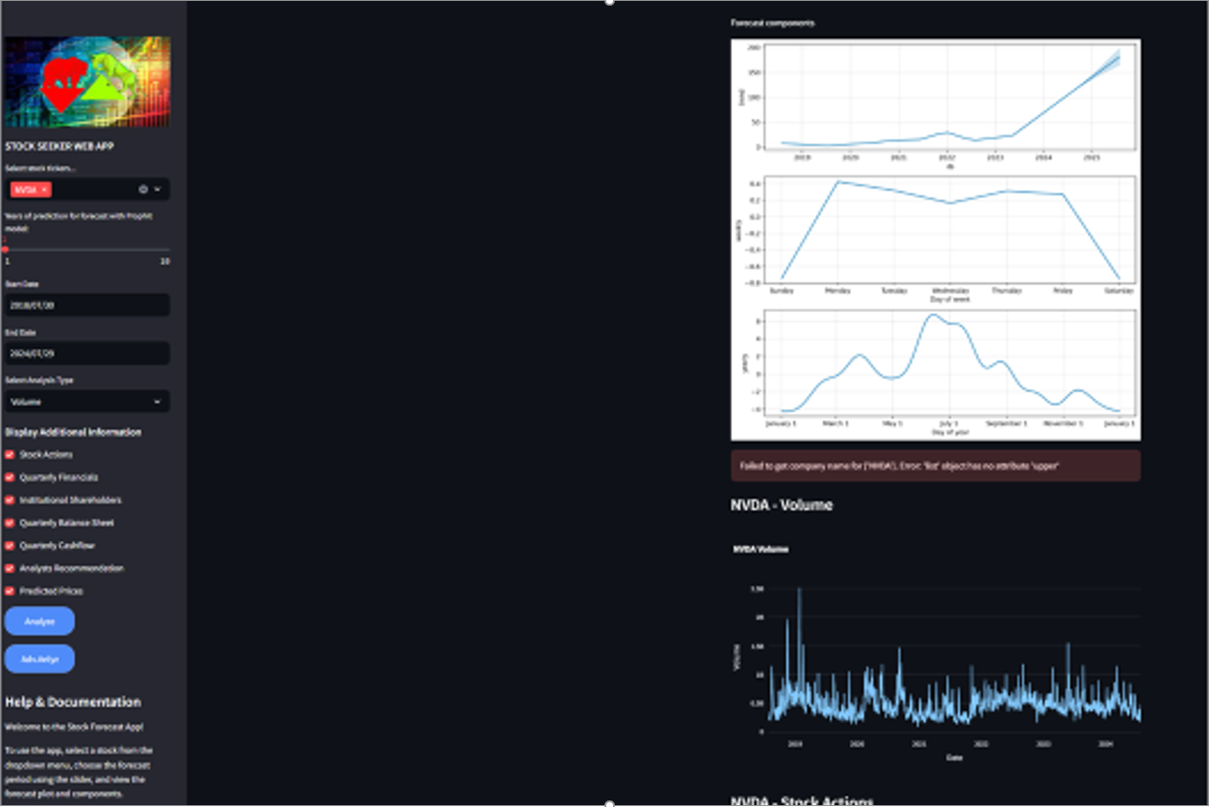

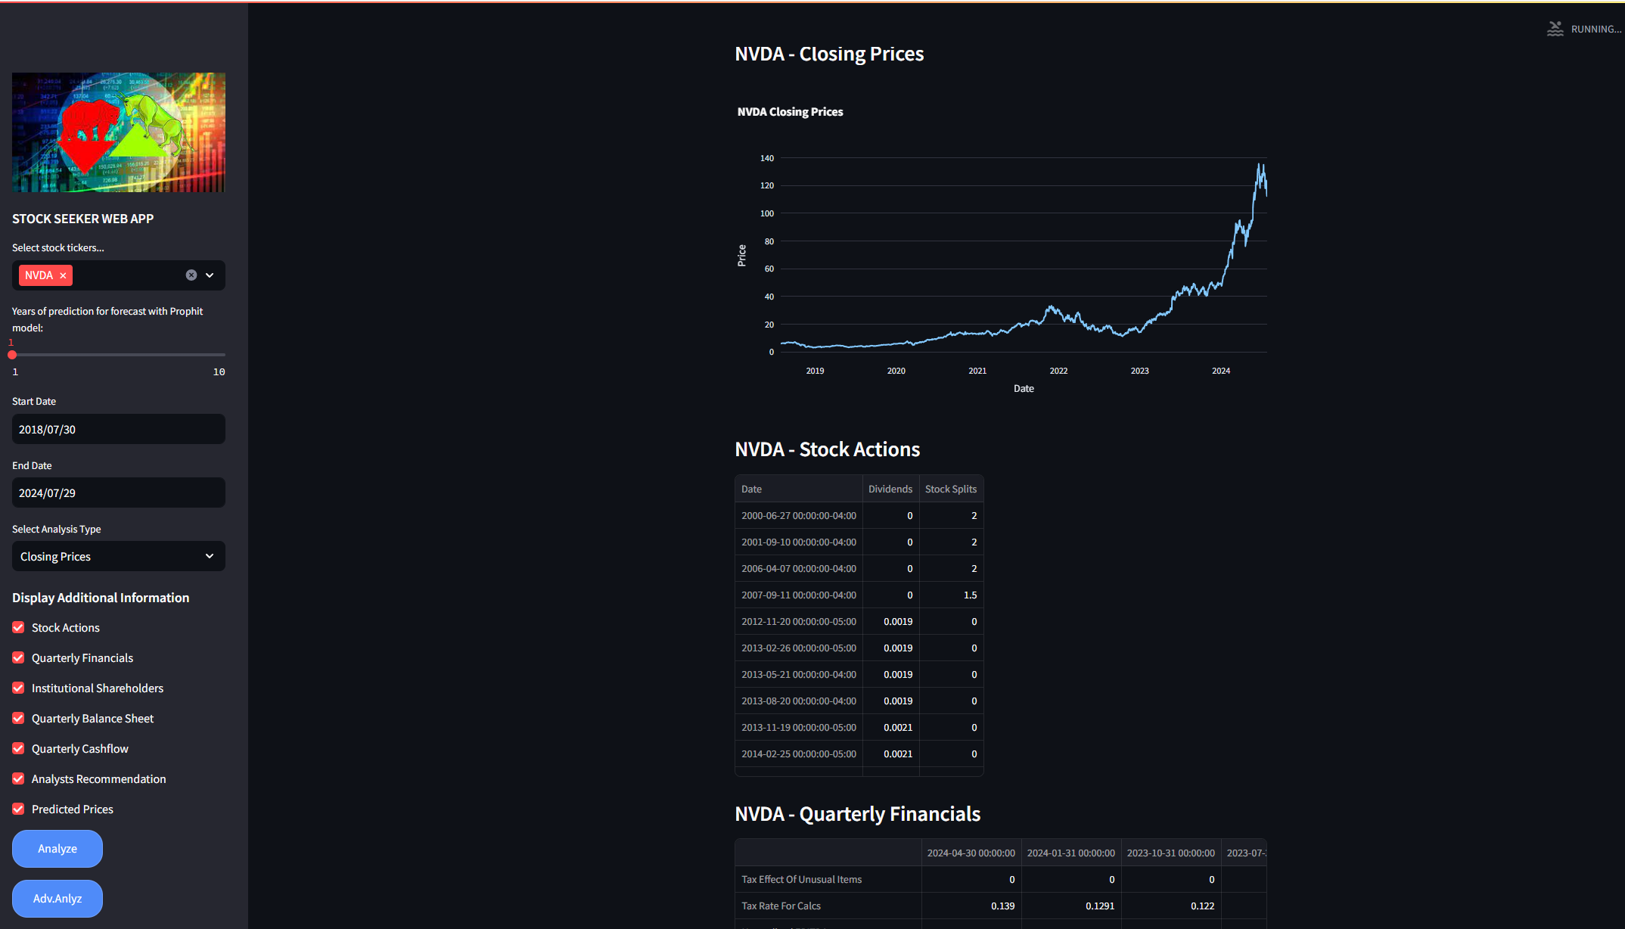

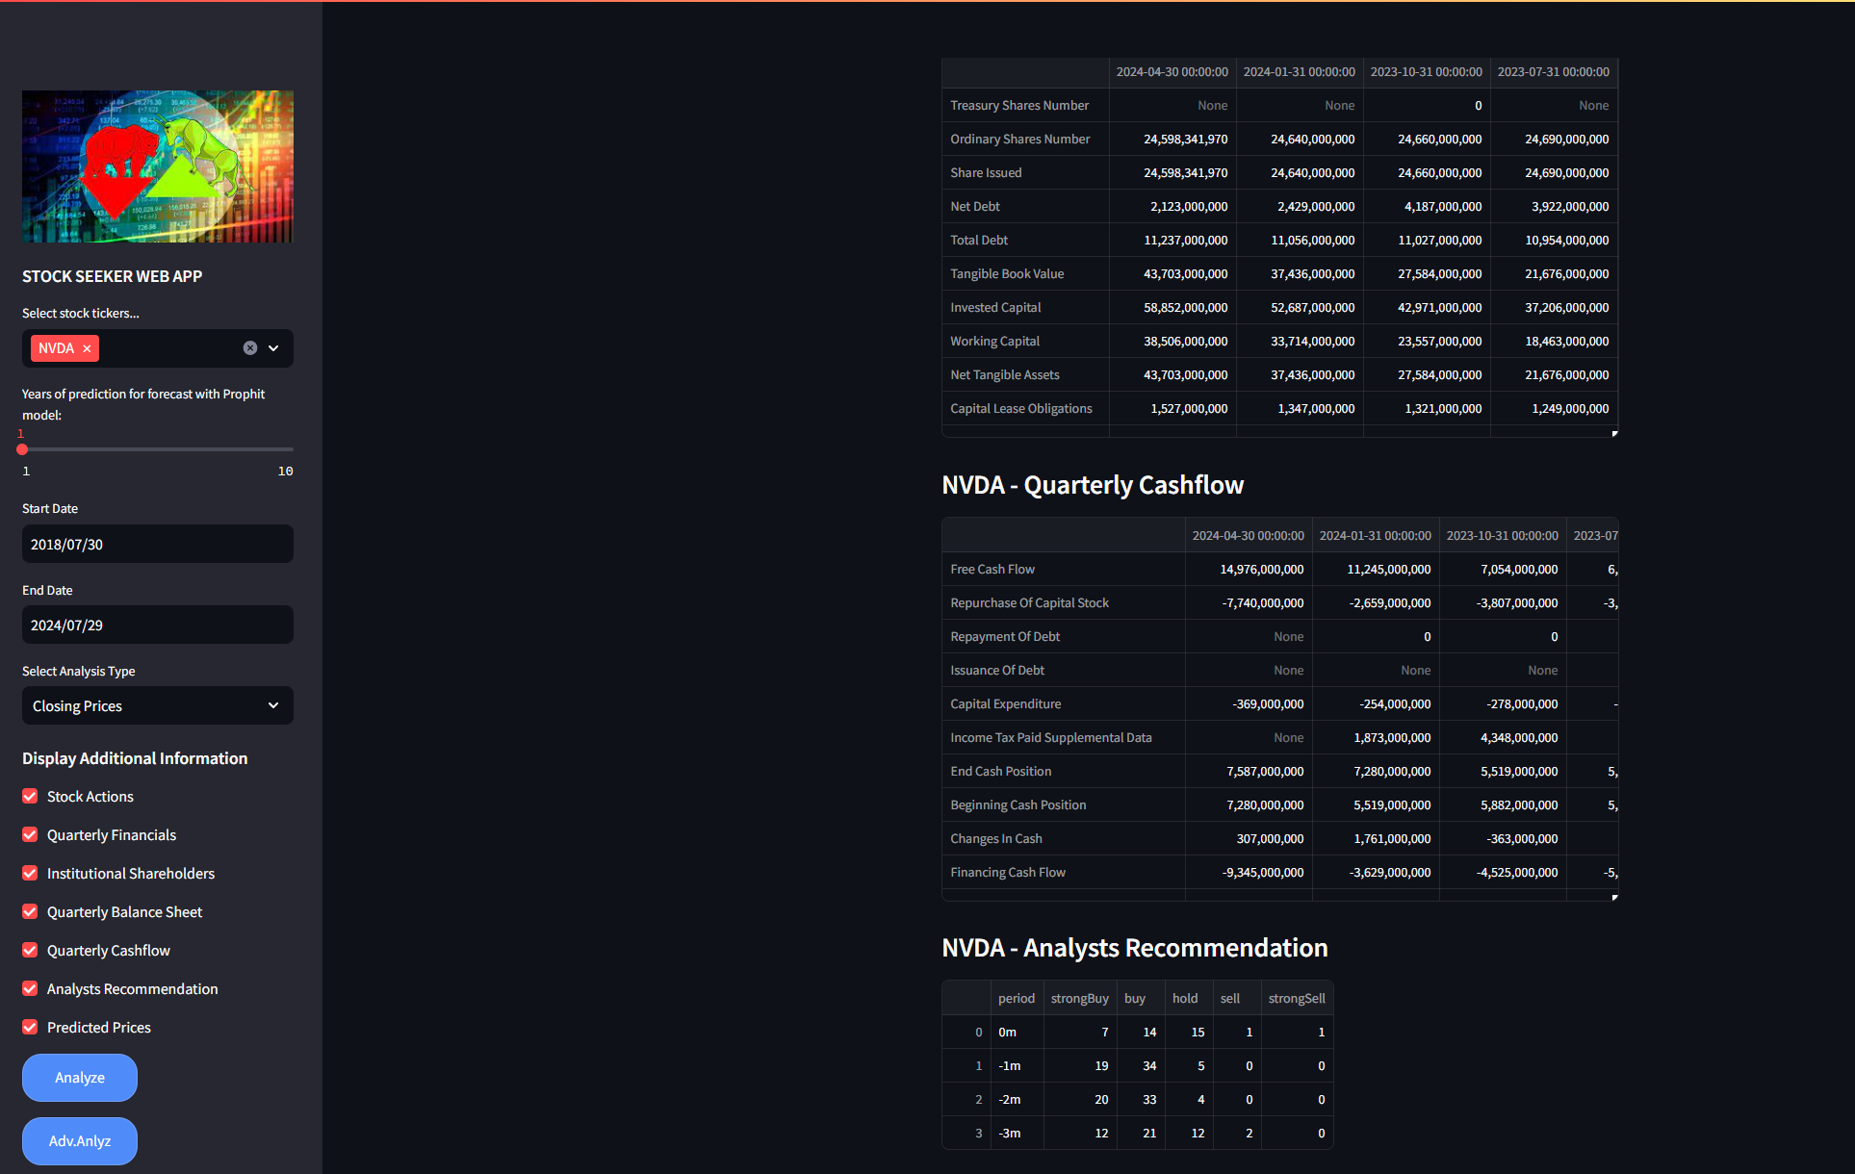

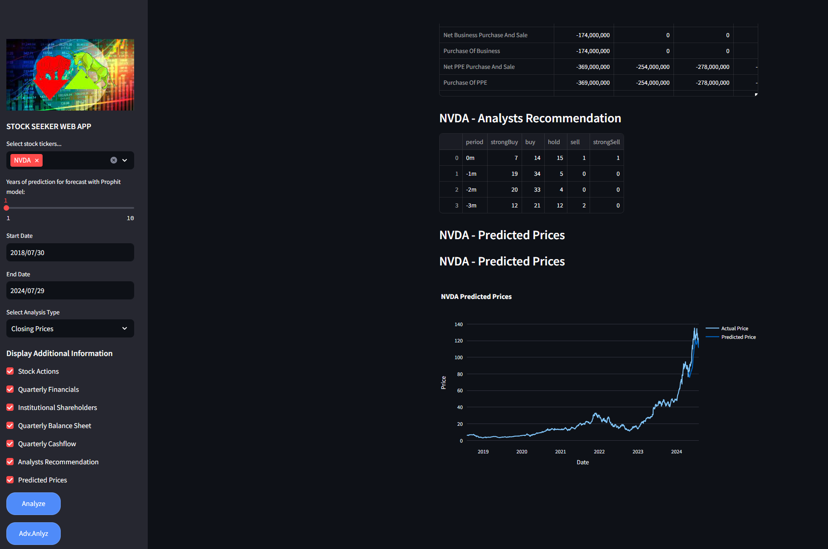

Second Screen:

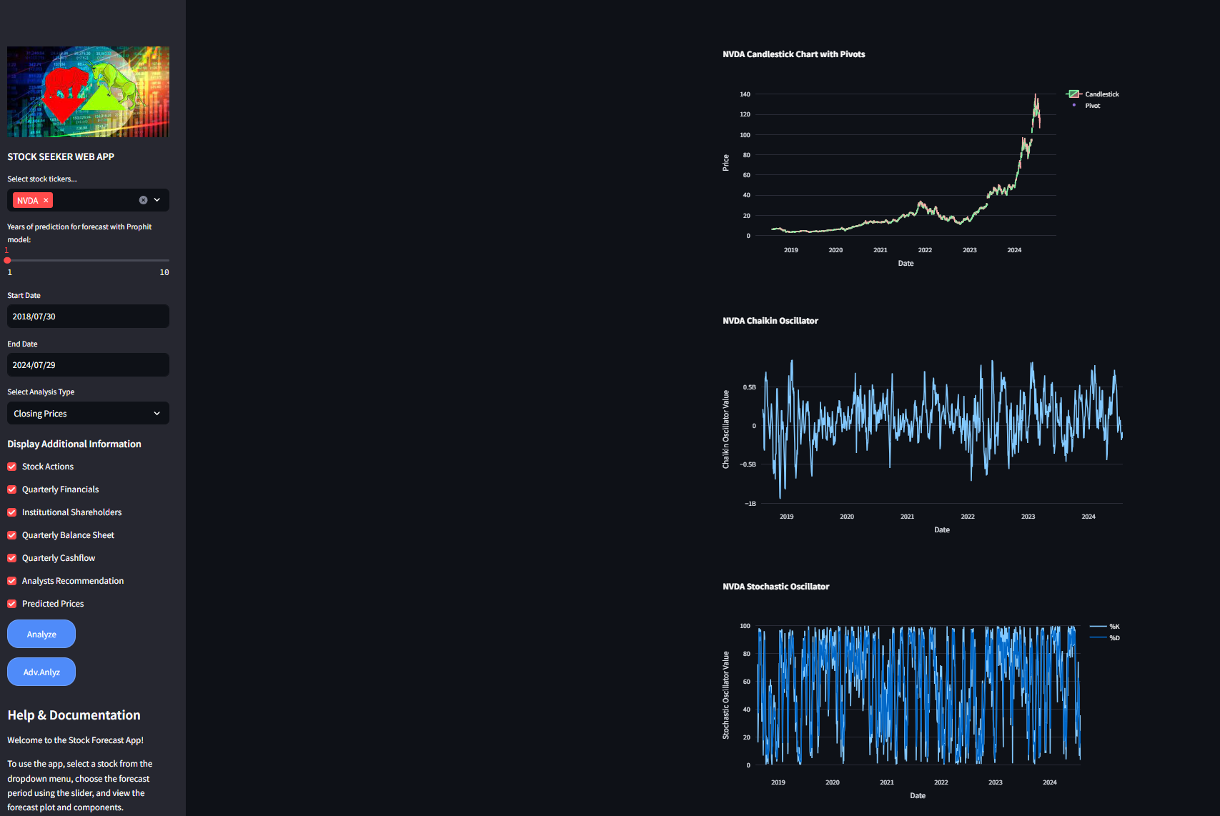

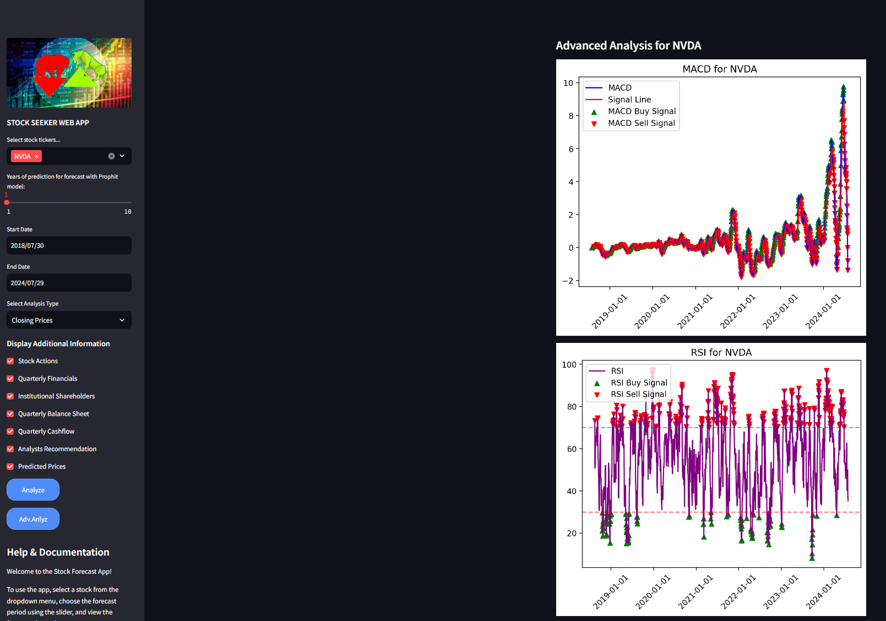

Finally, If an investor wants to obtain an analysis report, they can send an email as shown in the screenshot. After sending the email, we will share the detailed analysis report with them.



**ROAD MAP:**

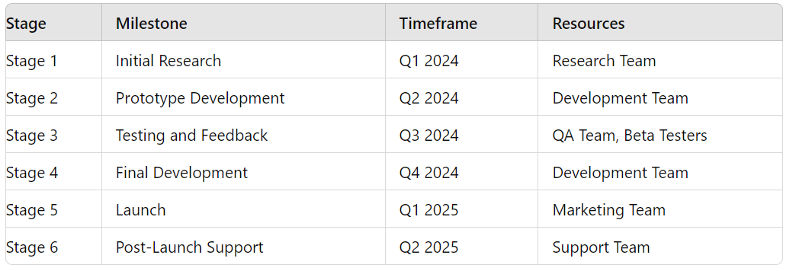

**Contact info:**

* [nejlayvazoglu@gmail.com](mailto:nejlayvazoglu@gmail.com)
* <https://www.linkedin.com/in/tessa-nejla-ayvazoglu/>
* GitHub: https://github.com/TessaAyv79